GCSE TestBank

This document contains test questions assessing the statements of the National Curriculum Programmes of Study as referenced in the Kangaroo Maths Stage 9 scheme of work, and their prerequisites.

The questions are arranged in the same order as the units of the Kangaroo Maths Stage 9 scheme of work.

The vast majority of questions are very closely modeled on the AQA Specimen Papers published in June 2015. A small number of questions are modeled on specimen papers from other exam boards.

Questions are coded as follows:

FC | Foundation paper, calculator allowed
FHC | Foundation and higher papers, calculator allowed
HC | Higher paper, calculator allowed
FN | Foundation paper, calculator not allowed
FHN | Foundation and higher papers, calculator not allowed
HN | Higher paper, calculator not allowed

1 Which of these numbers is one less than multiple of 7?
Circle your answer.
[FC, 1 mark]

15 | 57 | 27 | 35

2 Which of these numbers has exactly two factors?
Circle your answer.
[FC, 1 mark]

6 | 7 | 8 | 9

3 Kathy earns £10.50 per hour.
She works for

21 hours each week
46 weeks each year

She pays income tax if she earns more than £10 000 per year.

Does Kathy pay tax?

You must show your working.

[FC, 2 marks]

4 Which of these is a cube number?
Circle your answer.
[FC, 1 mark]

16 | 33 | 64 | 300

4 a) Use your calculator to work out $\frac{{12.42}^{2}+ \sqrt[3]{121}}{5.02}$

Write down your full calculator display.
[FHC, 1 mark]

Answer

4 b) Use approximations to check that your answer to part (a) is sensible.
You must show your working.
[FHC, 2 marks]

6 Work out the cube root of eight million.
Circle your answer.
[FHC, 1 mark]

20 | 200 | 2000 | 20000

7 Circle the decimal that is closest in value to $\frac{7}{9}$.
[FHC, 1 mark]

0.7 | 0.77 | 0.78 | 0.8

8 Written as the product of its prime factors 560 = 2⁴ × 5 × 7

8 a) Write 450 as the product of its prime factors
[HC, 2 marks]

Answer

8 b) Work out the value of the highest common factor of 560 and 450.
[HC, 1 mark]

Answer

9 The nth term of a sequence is 2^{n} + 2^{n – 1}
Work out the 10th term of the sequence.
[HC, 1 mark]

Answer

10 Is this statement true or false?

If x² = 9, the only value that x can be is 3

Tick a box.

 | True |  | False

Give a reason for your answer.
[FN, 1 mark]

Reason

11 Here are some properties of numbers:

A Square
B Triangular
C Prime
D Odd
E Even

11 a) Which two properties does the number 10 have?
Circle the correct letters
[FN, 1 mark]

A | B | C | D | E

11 b) Can a number have all of the properties?
Tick a box

 | Yes |  | No |  | Cannot tell

Give a reason for your answer.
[FN, 1 mark]

11 c) Write down a number with three of the properties.
State which properties it has
[FN, 2 marks]

Number
Properties | __________, __________, __________

12 a) Work out 1.9 × 0.003
[FN, 1 mark]

Answer

12 b) Write 3.45 × 10⁻² as an ordinary number
[FN, 1 mark]

Answer

12 c) Write 567 000 in standard form
[FN, 1 mark]

Answer

13 Work out $1\frac{2}{3}+3\frac{2}{5}$
Give your answer as a mixed number in its simplest form.
[FHN, 3 marks]

Answer

14 Simplify 4⁵ × 4⁷
Circle the answer.
[HN, 1 mark]

16³⁵ | 4¹² | 16¹² | 4³⁵

15 a × 10⁵ + a × 10³ = 181800 where a is a number

Work out a × 10⁴
Give your answer in standard form.
[HN, 2 mark]

Answer
16 Which shape is congruent to shape A?
[FC, 1 mark]

A
W | X
Y | Z

17 Which shape has diagonals that do not bisect each other?
Circle the correct letter.
[FC, 1 mark]

A | B | C | D

18 Here is some information about a triangle:

It has one line of symmetry
Its sides are whole number lengths
It has a perimeter of 13 cm

Sketch a diagram of a possible triangle.
Label each side with its length.
[FC, 2 marks]

19 Use ruler and compasses to answer this question.

Point X is
- the same distance from lines AB and AC
- 5 cm from point A

B
A
C

Show the position of point X on the diagram
[FHC, 3 marks]

20 Which of these is not the net of a cuboid?
Circle the correct letter.
[FN, 1 mark]
A | B
C | D

21 Shape M is a square.
A rectangle is cut from M to form shape N.
Not drawn accurately
Which one of these statements is true?
Tick a box.
[FN, 1 mark]
The perimeter of M is longer than the perimeter of N
The perimeter of M is the same as the perimeter of N
The perimeter of M is shorter than the perimeter of N
It is not possible to tell which perimeter is longer
22 a) Write an expression for the total cost, in pence, of

c cups of coffee at 180p each
and
t cups of tea at 150p each
[FC, 1 mark]

Answer

22 b) Simplify a + b × b + a
[FC, 1 mark]

Answer

23 Simplify 7b – (3b – 2)
Circle your answer
[FN, 1 mark]

4b – 2 | 2b | 4b + 2 | 6b

24 Here are four expressions.

x + y | y – x | xy | $$\frac{x}{y}$$
When x = -9 and y = 3 which expression has the greatest value?
You must show your working.
[FN, 3 mark]

Answer

25 Factorise x² + 9x + 14
[FHN, 2 marks]

Answer

26 ABEH is a rectangle
BCDE is a square
EFGH is a square
The three shapes are joined to make an L-shape.
Not drawn accurately
A |  |  | B |  |  |  |  |  | C
 |  |  |  |  |  |  |  |  | (x + 2) cm
H
 |  |  |  | E |  |  |  |  | D
G | 4 cm |  |  | F

Show that the total area of the L-shape, in cm², is x² + 8x + 28
[FHN, 4 marks]

27 How many centimetres are there in 2.9 metres?
Circle your answer
[FN, 1 mark]

290 | 29 | 0.29 | 0.29

28 The table shows the ratio of instructors to children needed for two activities

 | instructors : children
Kayaking | 1 : 5
Swimming | 1 : 8

28 a) There are 6 instructors at a swimming pool.
What is the greatest number of children that can go swimming?
[FN, 1 mark]

Answer

28 b) A group of 32 children want to go kayaking.
What is the smallest number of instructors needed?
[FN, 1 mark]

Answer

29 Solve 2x + 9 < 5x – 3
[FHN, 2 marks]

Answer

30 Ellie wants to buy a new bike for £499.
She has already saved £120.
Each week
her pay is £90
she saves 20% of this pay.

How many more weeks must Ellie save?
[FN, 4 marks]

Answer |  | weeks

31 Work out 61% of 300
[FN, 2 marks]

Answer

32 The diagram shows a semicircle of radius 10 cm
10 cm

Work out the area of the semicircle.
Give your answer in terms of π.
[FN, 2 marks]

Answer |  | cm²

33 The nth term of a sequence is 4n – 1
The nth term of a different sequence is 3n + 2

Work out three numbers that are
in both sequences
and
less than 100
[FHN, 3 marks]

Answer | __________, __________ and __________

34 A cycling club has 225 members.

48% are men.
36% are women.
The rest are children.

Work out the number of children in the club.
[FC, 3 marks]

Answer

35 Copper costs £3.20 per kilogram.
Tin costs £1.40 per kilogram.
Bronze is made using copper and tin in the ratio 9 : 1.

Work out the cost of the metal needed when making 45 kilograms of bronze.
[FHN, 4 marks]

Answer £

36 Which sequence is quadratic?
Circle your answer
[FHC, 1 mark]

1 1 2 3 | 2 4 8 14
2 4 6 8 | 100 50 25 12.5

37 Chris rides a bike 200 metres in 9.6 seconds.
Bradley says
“Chris could ride a bike 10 000 metres in 8 minutes.”

Tick a box to show whether this time for Chris to ride a bike 10 000 metres is likely to be accurate.

No, the time will be longer
Yes, the time will be 8 minutes
No, the time will be shorter

Give working and a reason to support your answer
[FC, 3 mark]

38 In a sale, the original price of a jacket was reduced by $\frac{1}{3}$.

The sale price of the jacket is £63.

Work out the original price of the jacket.
[FC, 3 marks]

Answer £

39 63 boys, 54 girls and 113 adults are members of a club.
20 more children join the club.
The number of girls is now 24% of the total number of club members.

How many of the 20 children were boys?
[FC, 4 marks]

Answer
40 The mass of 50 cm³ of aluminium is 135 grams.

Work out the mass of 80 cm³ of aluminium.
[FC, 2 marks]

Answer |  | grams

41 Two-stroke fuel is made by mixing petrol and oil.
Three bottles contain two-stroke fuel. The different mixtures are

A petrol : oil = 40 : 1

B oil = $\frac{1}{40}$

C oil = 0.04%

Which bottle has the smallest proportion of oil?
You must show your working.
[FC, 3 marks]

Answer

42 Mr Harrison drives to work for five days each week.

Each day he drives a total of 28.6 miles
His car travels 35.2 miles per gallon of petrol
Petrol costs 107.9 pence per litre
Mr Harrison discovers that a weekly bus ticket would cost him £23.65

Use 1 gallon = 4.5 litres

Is it cheaper for Mr Harrison to use his car or the bus to travel to work?
You must show your working.
[FC, 5 marks]

Answer

43 A company analyses its workforce and realises that

number of men : number of women = 3 : 5

There are 38 more women than men.

Work out the total number of people on the workforce.
[FHC, 3 marks]

Answer

44 Two types of eagle live in the UK.
The ratio of golden eagles to white-tailed eagles is 10 : 1.

44 a) What fraction of the eagles in the UK are golden eagles?
[FC, 1 mark]

Answer

44 b) In the UK there are 880 golden eagles.

How many eagles are there altogether in the UK?
[FC, 2 marks]

Answer

45 80 boys and 100 girls were asked if they cycled to school

Altogether $\frac{1}{3}$ of the pupils said yes.

$\frac{1}{5}$ of the girls said yes.

What fraction of the boys said yes?
[FHC, 4 marks]

Answer
46 y is inversely proportional to x.

Which graph shows this?
Circle the correct letter.
[FHC, 1 mark]

A | B
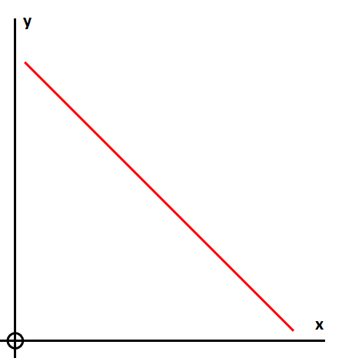 | 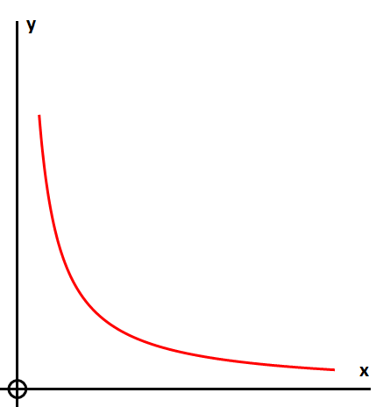
C | D
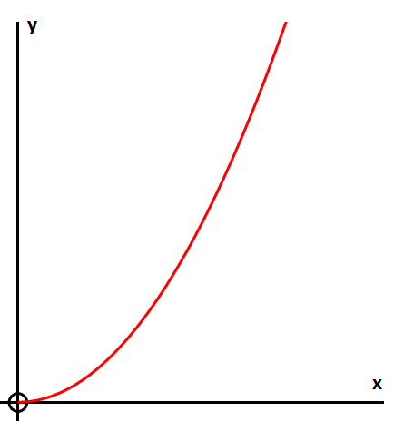 | 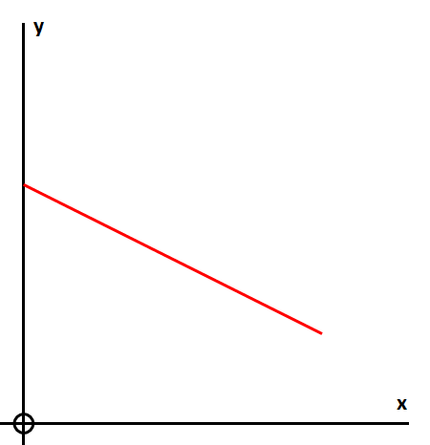

47 Triangle PQR is a right-angled triangle.
M is the midpoint of PQ.
Not drawn accurately
P
Q
R
M
8 cm
12 cm

Work out the length PM.
[FC, 3 marks]

Answer

