**histograms**

**EXPRESSIONS**

**a**

**Pythagroas**

**GRADE BUSTER**

*Your ‘5 a day’ mathematical workout*

1. The table contains the maths results for Class A:

a) Write down the modal class.

b) Write down the group containing the median.

c) Construct a histogram to represent the information.

|  |  |
| --- | --- |
| Exam percentage | Frequency |
| 0 ≤ x < 20 | 5 |
| 20 ≤ x < 50 | 9 |
| 50 ≤ x < 60 | 12 |
| 60 ≤ x < 80 | 15 |
| 80 ≤ x < 100 | 8 |

2. The table and histogram gives some information about the maths results for Class B.

Frequency density

|  |  |
| --- | --- |
| Exam percentage (%) | Frequency |
| 0 ≤ x < 10 | 5 |
| 10 ≤ x < 40 | 6 |
| 40 ≤ x < 50 |  |
| 50 ≤ x < 80 | 9 |
| 80 ≤ x < 100 |  |

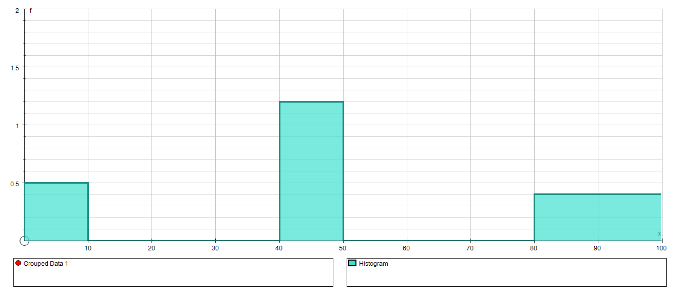

Exam %

a) Use the histogram to complete the frequency table.

b) Use the table to complete the histogram.

3. Find 3 other sets of data that could be represented by the histogram in Qu 2.

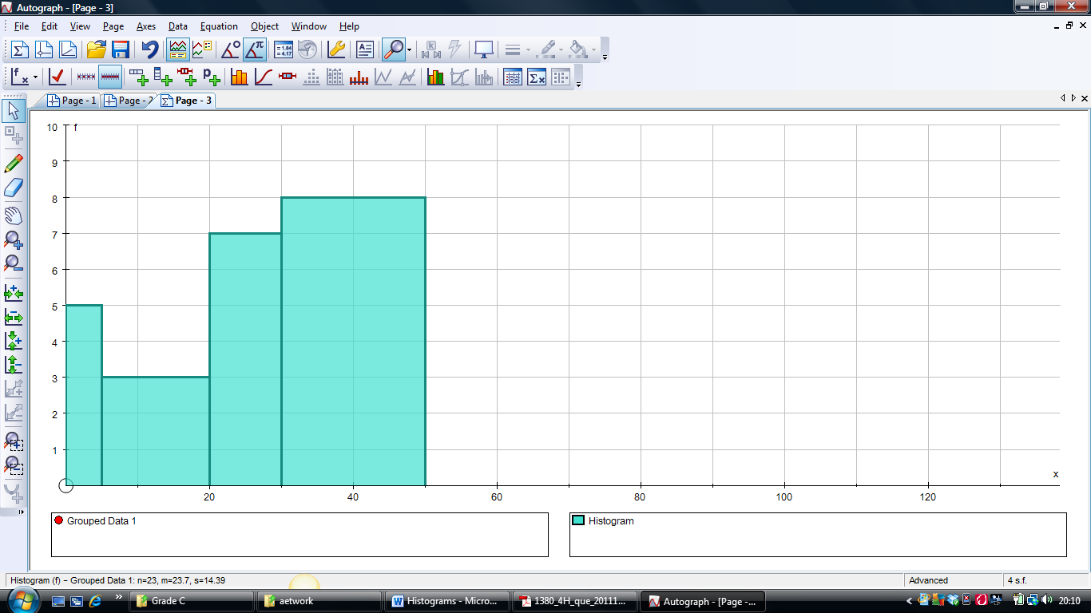 **

4. i) Explain what is wrong with the following solution:

Frequency

Construct a histogram:

|  |  |
| --- | --- |
| Temperature | Frequency |
| 0 ≤ x < 5 | 5 |
| 5 ≤ x < 20 | 3 |
| 20 ≤ x < 30 | 7 |
| 30 ≤ x < 50 | 8 |

Temperature

ii) Find the correct solution

5) Compare the distributions of Class A and Class B in question 1 and 2.

|  |  |  |  |
| --- | --- | --- | --- |
| Qu |  | ☺ | ☹ |
| 1, 3 & 4 | I can construct a histogram |  |  |
| 2 & 3 | I can extract information from a histogram |  |  |
| 5 | I can use histograms to compare distributions |  |  |

|  |
| --- |
| Top tips I must remember for the exam: |
| ☺  ☺  ☺ |
| Types of questions I need to practise more: |
| ☺  ☺  ☺ |