FREQUENCY FREQUENCY
EXPRESSIONS
BOX PLOTS &
EXPRESSIONS
CUMULATIVE FREQUENCY
EXPRESSIONS
B
Pythagroas
GRADE BUSTER

Your ‘5 a day’ mathematical workout
1. The box plot gives information about the maths results for Class A:
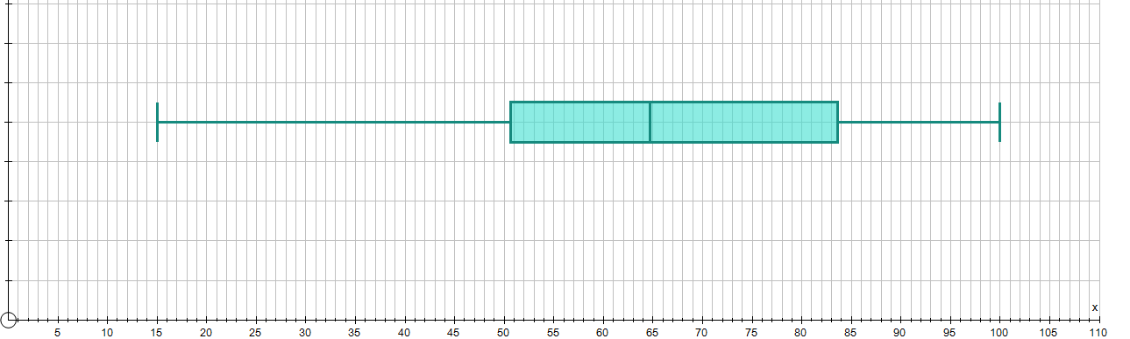
Exam %
a) Write down the median result.
b) Find the interquartile range of the results.
2. The table gives some information about the maths results for Class B:
Exam percentage (%) | Frequency
Lowest mark | 25
Lower quartile | 65
Median | 75
Upper quartile | 80
Highest mark | 90

On the grid above, draw a box plot to show this information.
3. Draw 3 other box plots with the same median and upper quartile range as Class B.

4. i) Explain what is wrong with the following solution:
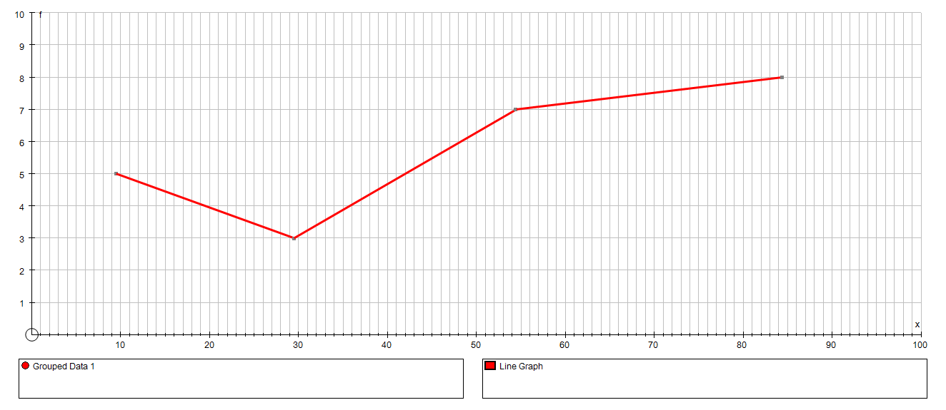

a) Construct a cumulative frequency curve:

Results (%) | Frequency
0 ≤ x < 20 | 5
20 ≤ x < 40 | 3  Frequency
40 ≤ x < 70 | 7
70 ≤ x < 100 | 8

b) Using the graph, estimate the median
Median = 19.5
Results %
result.

ii) Find the correct solution

5) Compare the results of Class A and Class B in questions 1 and 2.

Qu
1 & 5 | I can extract information from a box plot
2 & 3 | I can construct a box plot
4 | I can construct cumulative frequency curves
4 | I can use construct cumulative frequency curves to estimate the median
Top tips I must remember for the exam:
Types of questions I need to practise more:

