- Which line represents the hare?
- Which line represents the tortoise?
- Describe the race in detail.

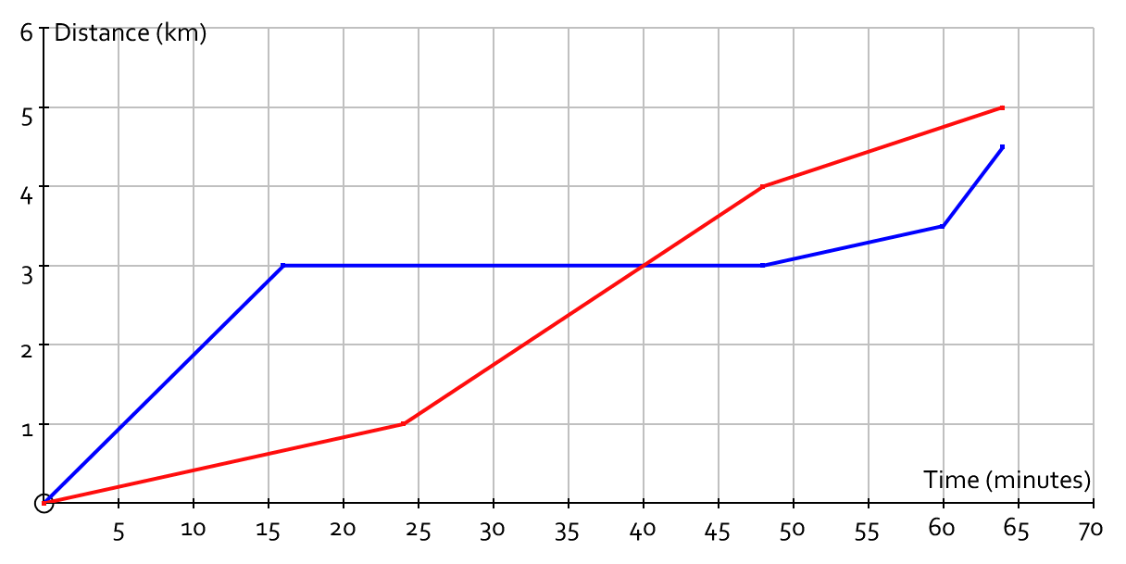

A possible response?
Harold Hare starts quickly but, at the top of a hill, falls asleep under a tree
Tommy silently plods past Harold and wanders off down the hill towards the finish line
Tommy is getting puffed out, and his startling rate slows down a bit
Tommy Tortoise spots the sleeping hare ahead, and puts on a burst of acceleration
Harold wakes up and sees he is behind. Unfortunately, he has slept awkwardly, has pins and needles in his left foot, and is slowed as a result
The pins and needles wears off, and Harold charges towards the chequered flag. But Tommy just finishes the 5 km course before he is caught

