**Swedish numbers**

# Helge von Koch was from Sweden. He would have known these facts about the numbers 1 to 10:

Ett, nio and fyra are **square numbers**

Sju, två, fem and tre are **prime numbers**

Åtta and ett are **cube numbers**

Tio, ett, sex and tre are **triangular numbers**

Två + två = två × två = fyra

Ett + två + tre = ett + två + tre = sex

Sju – fem = två

Decrypt the number problems and match each word to the correct number

|  |  |  |  |  |  |
| --- | --- | --- | --- | --- | --- |
| **1** |  | **4** |  | **8** |  |
| **2** |  | **5** |  | **9** |  |
| **3** |  | **6** |  | **10** |  |
|  |  | **7** |  |  |  |

**Swedish money**

“*After a nearly decade-long slide in Swedish students' maths skills, the government has decided to invest 2.6 billion krona ($404.9 million) to raise results in Swedish schools*.”

*source:* [*http://www.thelocal.se*](http://www.thelocal.se/)

Use this headline to complete the following exchange rates:

1 US dollar = ______ Swedish krona

1 Swedish krona = ______ US dollars

On 24th September 2013, 1 UK pound was equivalent to 1.60 US dollars. Use this fact to complete the following exchange rates:

1 UK pound = ______ Swedish krona

1 Swedish krona = ______ UK pound

**Swedish flag**

The Swedish flag is based on a rectangle with sides in the ratio 5:8

The horizontal divisions are in the ratio 5:2:9

The vertical divisions are in the ratio 4:2:4

Construct an accurate flag of Sweden using a rectangle that is 16 cm from left to right

The Swedish naval flag is based on a rectangle with sides in the ratio 1:2

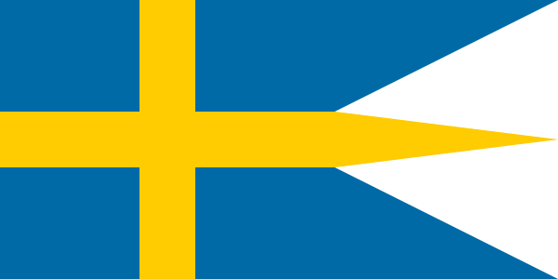The horizontal divisions are in the ratio 5:2:5:8

The vertical divisions are in the ratio 4:2:4

Construct an accurate naval flag of Sweden using a rectangle that is 10 cm from top to bottom

*David Newton /* [*CC-BY-SA-3.0*](http://creativecommons.org/licenses/by-sa/3.0/)

**The Koch Snowflake**

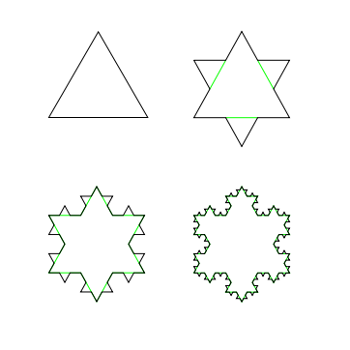Helge von Koch was a mathematician who invented one of the world’s first fractals. It is called the Koch Snowflake or Koch Island.

To create the first few steps of this design:

* Construct an equilateral triangle
* Split each side into three equal lengths
* On each side, use the middle length to create another (3 times smaller) equilateral triangle
* Repeat for each side of the new shape

Build a (step 3) Koch Snowflake using an equilateral triangle with side length 9 cm as your starting point. Use isometric paper for your design.

[*CC-BY-SA-3.0*](http://creativecommons.org/licenses/by-sa/3.0/)

**Challenge**! Start with a triangle with 27 units as the side length and build to step 4.

If this process is continued indefinitely you have a shape with an infinite perimeter which encloses a fixed area.

Amazingly, you can create a tessellation with two different sized Koch Snowflakes

