**Polish numbers**

Mandelbrot was born in Poland. He would have known these facts about the numbers 1 to 10:

* Dziewięć, jeden and cztery are **square** numbers
* Dziesięć, trzy, jeden and sześć are **triangular** numbers
* Jeden + trzy + dwa = jeden × trzy × dwa
* Dziesięć ÷ dwa = pięć
* Dziewięć × cztery = sześć × sześć
* Osiem – pięć = sześć ÷ dwa
* Cztery + siedem = cztery × trzy – jeden
* Trzy × trzy = dziewięć

Decrypt the number problems and match each word to the correct number

|  |  |  |  |  |  |
| --- | --- | --- | --- | --- | --- |
| **1** |  | **4** |  | **8** |  |
| **2** |  | **5** |  | **9** |  |
| **3** |  | **6** |  | **10** |  |
|  |  | **7** |  |  |  |

**How Long is the Coastline of Britain?**

Mandelbrot’s early studies into ‘self-similar’ shapes started with this question. Using the different ‘rulers’ provided here, **how long** is the coastline in each case?

**How many times longer** is the coastline when measured with the 50km ruler compared with the 200km ruler?

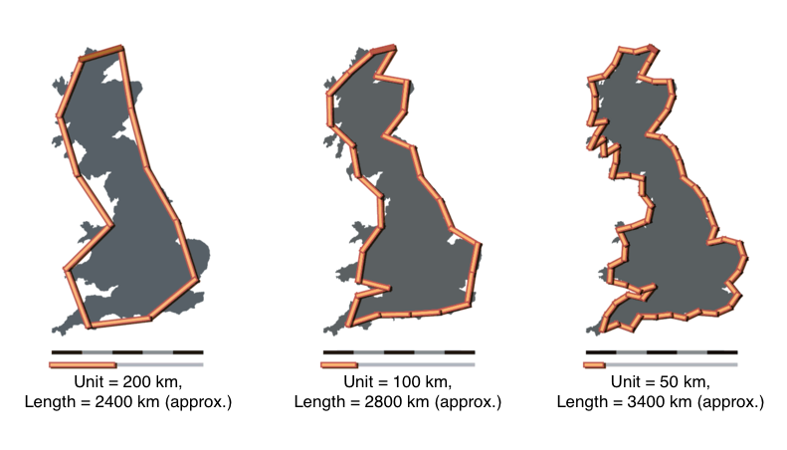

*Image © User: Avsa (mixed by Acadac) / Wikimedia Commons /* [*CC-BY-SA-3.0*](http://creativecommons.org/licenses/by-sa/3.0/)

**Wiggly Coastlines: where to live if you like the beach**

The World Factbook lists countries by the length of their coastlines. The top 15 are shown in the table, along with their areas.

Because the countries are so different in size (land area), the table does not tell us which country has the wiggliest coastline. We can use the numbers to help us work this out.

One way to work out the wiggliness of the coastline is to work out the number of metres of coast for every square kilometre of area. Work out this ‘wiggliness ratio’ for each country. You could use a spreadsheet to speed things up.

List the 15 countries in order of wiggliness of coastline.

|  |  |  |  |  |
| --- | --- | --- | --- | --- |
| **Rank** | **Country** | **Land area (km²)** | **Coastline (km)** |  |
| 1 | Canada | 9,093,507 | 202,080 |  |
| 2 | Indonesia | 1,811,569 | 54,716 |  |
| 3 | Russia | 16,377,742 | 37,653 |  |
| 4 | Philippines | 298,170 | 36,289 |  |
| 5 | Japan | 364,485 | 29,751 |  |
| 6 | Australia | 7,682,300 | 25,760 |  |
| 7 | Norway | 304,282 | 25,148 |  |
| 8 | United States | 9,161,966 | 19,924 |  |
| 9 | New Zealand | 267,710 | 15,134 |  |
| 10 | China | 9,569,901 | 14,500 |  |
| 11 | Greece | 130,647 | 13,676 |  |
| 12 | United Kingdom | 241,930 | 12,429 |  |
| 13 | Mexico | 1,943,945 | 9,330 |  |
| 14 | Italy | 294,140 | 7,600 |  |
| 15 | Brazil | 8,459,417 | 7,491 |  |

*Note that there is no standard ruler length used here. Another ‘reliable’ source gives the coastline of the UK as a whopping 19,717km.*

**The Mandelbrot Set**

After pondering on the coastline problem, Mandelbrot moved on to iterative formulae. Here was his favourite:

zn+1 = zn2 + c

Iteration means doing things over and over again. In this case we always start with z0 = 0 and take c = 1. Substituting these values into the formula gives z1 = 1. This value is now used (along with c = 1 again) to get z2. And so on.

We end up with a sequence z0, z1, z2, z3, z4, … Using z0 = 0 and c = 1, find the first five terms in the iterative sequence.

Find the first five terms of the sequence if:

* c = 2
* c = 0.5
* c = 0.1

Write down all the digits on the calculator screen rather than rounding. You could use a spreadsheet to help

Mandelbrot discovered that some starting numbers resulted in a sequence that approached a single value (converged) and some starting numbers resulted in a sequence that continued growing towards infinity (diverged). When he also used complex numbers as a starting point, a diagram of the results gave an amazing pattern with self-similar features. This diagram is called the Mandelbrot Set, and is one of the most famous fractals.

* Watch this video of it in action: <http://vimeo.com/6035941>
* And experiment with how it is constructed [here](http://www.easyfractalgenerator.com/mandelbrot-set-generator.aspx):

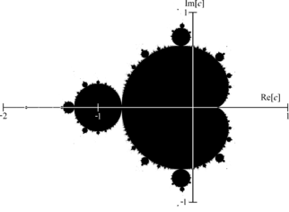

*source: en.wikipedia.org*

**Gaskets and Carpets, Sponges and Snowflakes**

Another Polish mathematician, Sierpinski, explored a pattern which turned out to be fractal too. The first few steps to construct one are shown here:

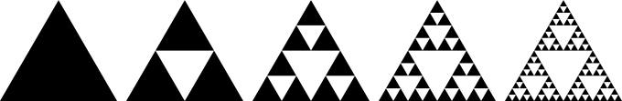

*source: en.wikipedia.org*

Use triangular paper to construct this ‘**Sierpinski Triangle**’ (or Gasket) as it is known. You will need to choose sensible dimensions.

The **Sierpinski Carpet** is similar. Starting with a square, a smaller square one third of the size is removed from the middle. The process is repeated with each of the eight squares that remain. And so on. Construct the first few steps of one of these.

* Search online for a Sierpinski Triangle made out of coke cans
* The **Menger Sponge** is a 3D version of the Sierpinski carpet. Search online for a model of one that has been made using 66,000 business cards. You might also find the Post-It Menger Sponge amusing.
* Find out about the **Koch Snowflake**

**Pascal’s Triangle**

Okay, I hear what you are thinking. Why is Pascal’s Triangle making an appearance here? Well, try this:

1) Take a sheet of centimetre squared paper.

2) Using a single square for each number, write down the first 16 rows of Pascal’s Triangle

3) Use a coloured pencil to shade in all the odd numbers

4) What do you notice?

* Of course, rather than write down the actual numbers in the first 16 rows, you could just write ‘odd’ or ‘even’.
* Experiment with multiples of different numbers. What patterns can you find?
* You could use a spreadsheet to help. Take a look at this one: <http://www.kangaroomaths.com/free_resources/history/pascal2.xls>