Profile: Thales of Miletus

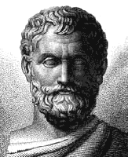 | Name: Thales  Born: c. 624 BC  Died: c. 546 BC  Lived: Miletus (now in Turkey)  Job: Philosopher and Mathematician  Known for:  - Proving Thales’ Theorem and sacrificing an ox  - Stopping a war by predicting an eclipse of the sun  - Being the ‘Father of Science’

The Theorem

Look at the diagram on the left.

A, B and C are points on a circle.
If AC is a diameter then angle ABC is a right-angle.

Sometimes, this is remembered as ‘the angle in a semicircle is a right angle’.

Set-square challenge
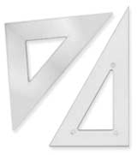 | How can you use a set-square to find the centre of this circle?  Hint: Thales’ Theorem will help you!

Prove it!

This diagram to show Thales’ Theorem has had an extra line, OB, drawn in.

Now look at the eight statements below. Place them in an order which prove that Thales’ Theorem is true

so x + (x+y) + y = 180˚
Now, angles in a triangle sum to 180˚
so x + y = 90˚
Also, ∠OBC = ∠OCB. Label these ‘y’.
Therefore triangles OAB and OBC are isosceles.
OA, OB and OC are radii of the circle.
so 2x + 2y = 180˚
This means that ∠OAB = ∠OBA. Label these ‘x’.

