150°
150° + 180°
= 330°

North
North
Birmingham airport’s runway has the number ‘15’ at one end. This tells the pilot that the required bearing for the approach is 150°. The number ‘33’ is at the other end.

Find it here

Task 1

For each of the following airports, one number at the end of a runway is given. Find the number at the other end. Draw a diagram to help explain the reasoning.

- Newcastle: 07
- Helsinki: 04
- Manchester: 23
- Sydney: 16
- Inverness: 30
- Singapore: 20

Task 2

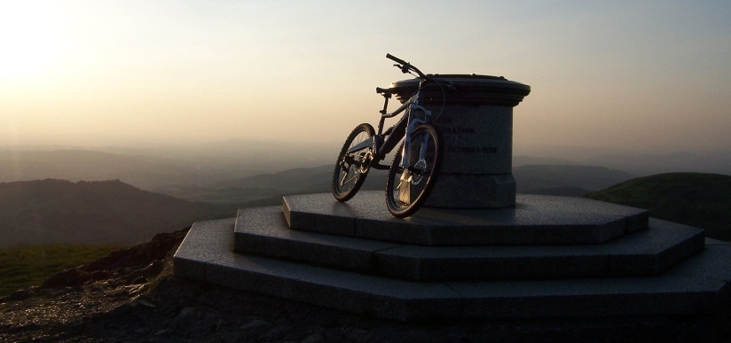
Bear this in mind …

To use a bearing correctly:
- Measure from North
- Measure clockwise
- Always use three figures

Over the page there is some information taken from the toposcope on the Worcestershire Beacon. For each place, measure the bearing and write a sentence such as:

Brown Clee Hill is 27 miles from the Worcestershire Beacon on a bearing of ______°

Brown Clee Hill
27 miles
Stourport-on-Severn
15 miles
Worcester
8 miles
35 miles
Hay Bluff
13 miles
Bredon Hill
Tewkesbury
11 miles
Monmouth
25 miles
N

Task 3

You will need to create scale diagrams in order to solve these problems. Choose a sensible scale and use a sharp pencil, ruler and protractor. You also need compasses for question 3.

- An aeroplane leaves an airport and flies 600 km on a bearing of 032°. It then changes to a bearing of 281° and flies 550 km.
- At the point where the aeroplane was due North of the start, how far was it from the airport?
- What is the straight line distance between the start point and end point of the flight?

- An aeroplane flies 240 km on a bearing of 107°, then 420 km on a bearing of 071°, and finally 500 km on a bearing of 295°.
- What is the bearing of the end point of the journey from the start point?
- What distance would the pilot have flown if he had been able to travel directly?

- A pilot intends to fly between airports for 600 km on a bearing of 195°. After 500 km, air traffic control informs him that he is actually 180 km from the airport. Assuming that he has flown in a straight line:
- Mark the aeroplane’s two possible positions on a diagram.
- Find the two possible bearings for the flight.

