8 cm  4 cm  A logo design is made from two circles  Find the area of the shaded shape | A semicircle has diameter 12 cm  Find the perimeter of the semicircle  12 cm
4 cm  5 cm  A shape is made from a rectangle and a semicircle. The radius of the semicircle is 5 cm.  Find the length of the longest side of the rectangle. Find the area of the shape. | Find the area of the quadrant  Write your answer in terms of π  8 cm
d = 8 cm  d = 6 cm  The ‘annulus’ is made by removing a circle from the centre of a larger circle  Find the area of the annulus. Write your answer in terms of π. | The diameter of a bike wheel is 67 cm  How many times does it turn in 120 metres?  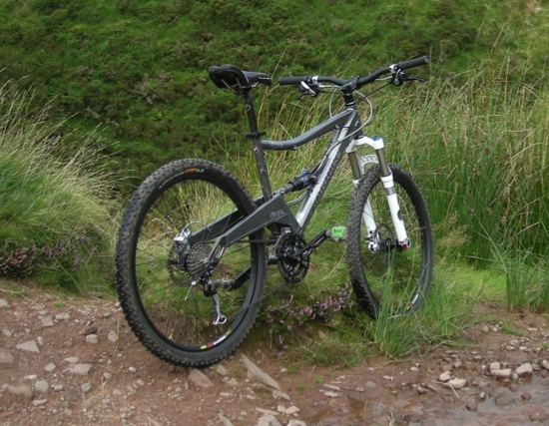

- Solve each of the circle problems on page 1

- The answers are shown here. They are jumbled up. You need to match each problem to its solution.

- The units of the answer are not shown. In your solution, you need to find the correct unit too.

79.3 | 7π
57.0 | 37.7
16π | 30.8
answers have been rounded when not in terms of π

- Write up each problem in your book. Make sure that you clearly explain each step of the working.

- What other problems could you solve using these shapes?

