Bronze

Look at each set of triangles. Write the letters of the congruent pair in each case.

1 | 2
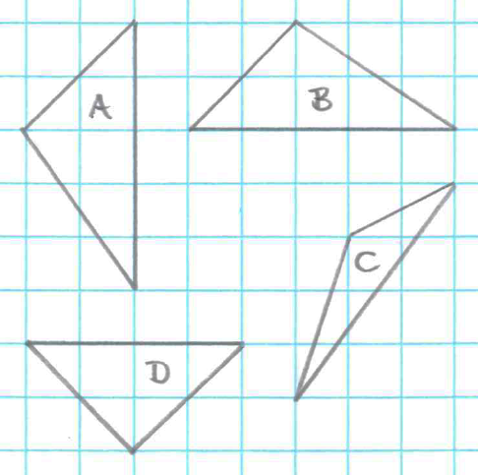 | 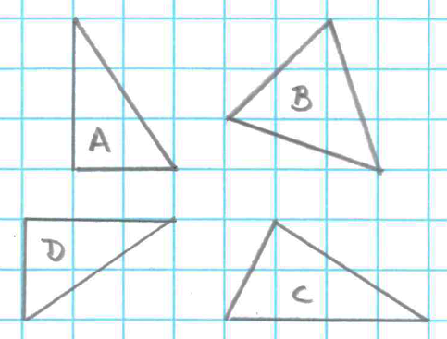
3 | 4
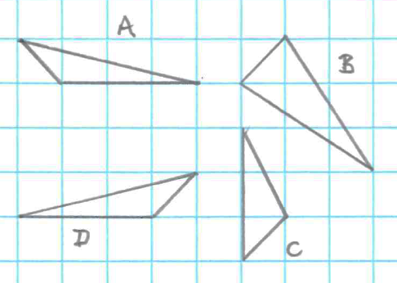 | 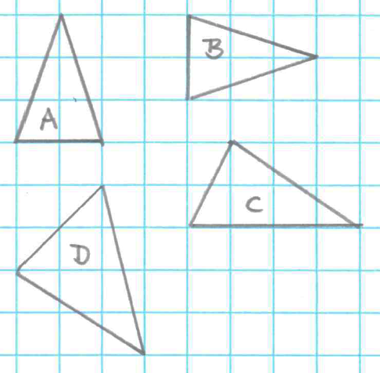
5 | 6
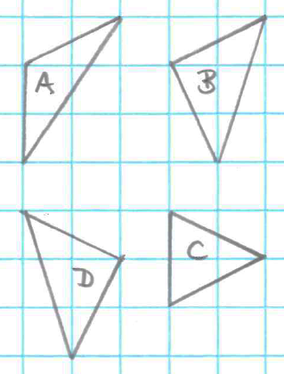 | 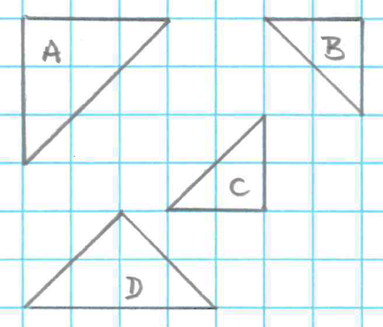

Silver

Look at each set of triangles. Identify a pair of congruent triangles - if possible.
When it is possible, write the condition that proves they are congruent.

1 | 2
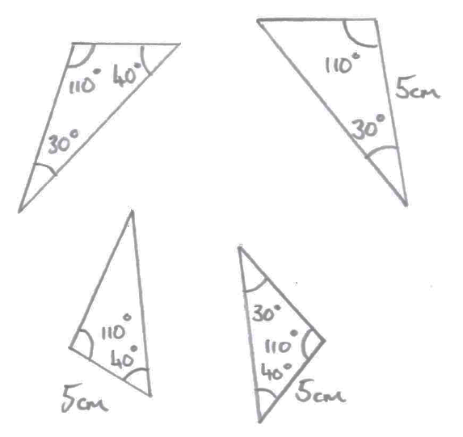 | 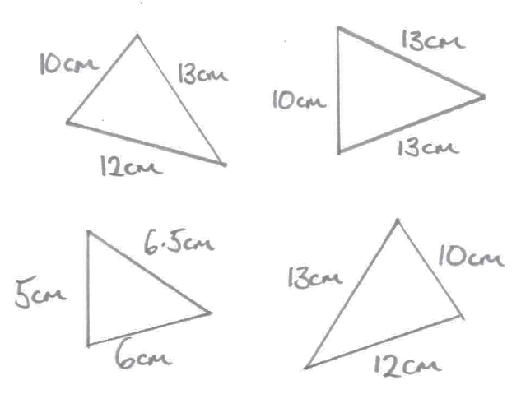
3 | 4
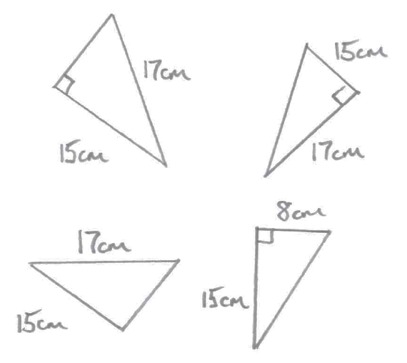 | 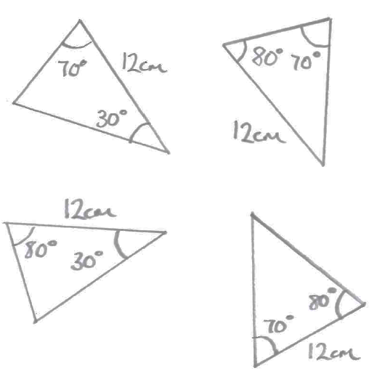
5 | 6
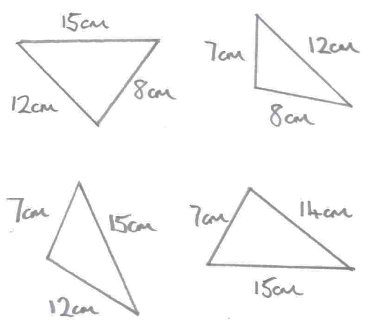 | 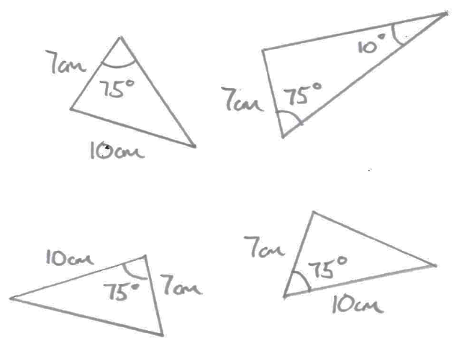
Gold

You are given information about a pair of triangles.
Decide whether the pair of triangles is congruent or not.
If they are, state the condition that proves they are congruent.

1
AC = 10 cm  BC = 6 cm  ∠ABC = 45° | and | PQ = 6 cm  PR = 10 cm  ∠QPR = 45°
2
AC = 12 cm  AB = 13 cm  ∠ACB = 90° | and | LN = 13 cm  MN = 12 cm  ∠LMN = 90°
3
∠DEF = 70°  ∠DFE = 70°  ∠EDF = 40° | and | ∠XYZ = 70°  ∠XZY = 40°  ∠YXZ = 70°
4
BC = 12 cm  ∠ABC = 85°  ∠ACB = 41° | and | XZ = 12 cm  ∠XYZ = 54°  ∠XZY = 85°
5
QR = 12 cm  ∠PQR = 100°  ∠PRQ = 25° | and | XY = 12 cm  ∠XYZ = 25°  ∠YXZ = 100°
6
AB = 9 cm  AC = 8 cm  ∠BAC = 55° | and | DE = 8 cm  EF = 9 cm  ∠DEF = 55°

Answers

Bronze
- A and B
- A and D
- A and D
- A and B
- B and D
- B and C

Silver
- ASA
- SSS
- RHS or SSS if Pythagoras’ theorem applied
- ASA
- None congruent
- SAS

Gold
- Not congruent
- RHS or SSS if Pythagoras’ theorem applied
- Not congruent
- Not congruent
- ASA
- SAS

