|  |  |
| --- | --- |
| **Examining angles** | *Mostly Edexcel questions, some AQA* |
| **Bronze** | |

**1.**

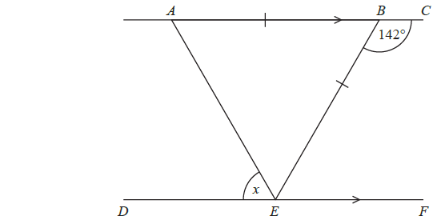

*ABC* and *DEF* are parallel straight lines.

*ABE* is an isosceles triangle with *AB* = *BE*.

Angle *CBE* = 142°

Work out the size of angle *x*.

Give a reason for each stage in your working.

**2.**



*BPCD* is a straight line.

*BA* is parallel to *CQ.*

*AP* is perpendicular to *BC.*

Angle *ABC* = 54°

Angle *ACQ* = 76°

Work out the size of the angle marked *x.*

Give reasons for your answer.

**3.**



*ABC* is parallel to *EFGH*.

*GB* = *GF*

Angle *ABF* = 65°

Work out the size of the angle marked *x*.

Give reasons for your answer.

**4.** The diagram shows part of the design of a stained glass window.

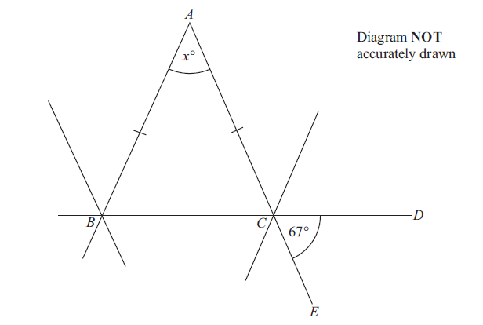

*ABC* is an isosceles triangle. *BCD* and *ACE* are straight lines. Angle *DCE* = 67°.

Work out the size of the angle marked *x*°. Give reasons for your answer.

**5.**



*ABC* is a straight line.

*DEFG* is a straight line.

*AC* is parallel to *DG*.

*EF = BF*.

Angle *BEF* = 50°.

Work out the size of the angle marked *x*.

Give reasons for your answer.

**6.**

**

*ABCDE* is a regular pentagon.

*BCF* and *EDF* are straight lines.

Work out the size of angle *CFD*.

You must show how you get your answer.

|  |
| --- |
| **Silver** |

**1.**

**

*ABCD* is a parallelogram.

*EDC* is a straight line.

*F* is the point on *AD* so that *BFE* is a straight line.

Angle *EFD* = 35°

Angle *DCB* = 75°

Show that angle *ABF* = 70°

Give a reason for each stage of your working.

**2.** The diagram shows a triangle.

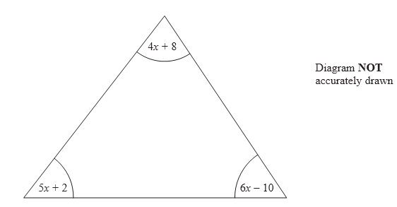

All the angles are measured in degrees.

Show that the triangle is isosceles.

**3.** In the diagram, *AB*, *BC* and *CD* are three sides of a regular polygon **P**.

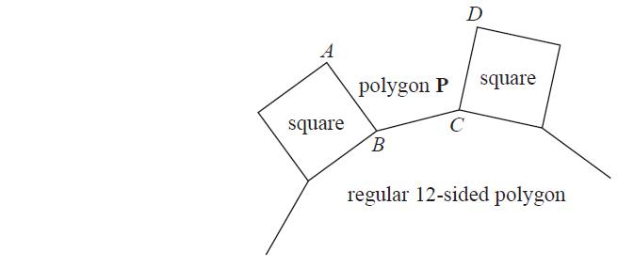

Show that polygon **P** is a hexagon.

You must show your working.

**4.** *AB*, *CD* and *YZ* are straight lines.

All angles are in degrees.

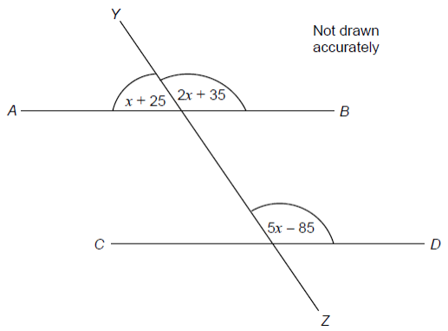

Show that *AB* is parallel to *CD*

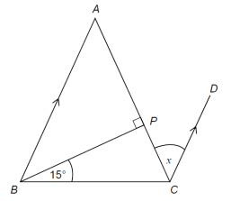

**5.** *ABC* is a triangle with *AB* = *AC*

*BA* is parallel to *CD*.

Show that angle *x* = 30°.

|  |
| --- |
| **Gold** |

**1.** *ABD* is a right-angled triangle.

**

*C* is the point on *BD* such that angle *ACB* = 90°.

Prove that triangle *ABD* is similar to triangle *CBA*.

**2.** The diagram shows a quadrilateral *XBYA.*

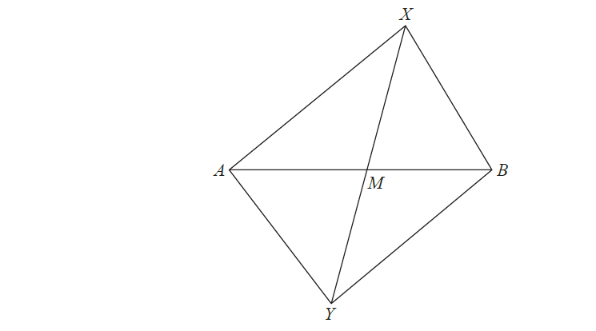

The diagonals AB and XY intersect at the point M.

Given that the area of triangle AXB is equal to the area of triangle AYB, prove that XY is bisected by AB.

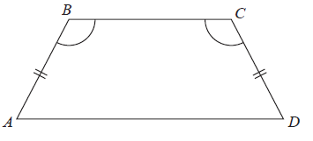**3.** *ABCD* is a quadrilateral.

*AB* = *CD*.

Angle *ABC* = angle *BCD*.

Prove that *AC* = *BD*.

**4.**



*ABC* is an equilateral triangle.

*D* lies on *BC*.

*AD* is perpendicular to *BC*.

**(a)** Prove that triangle *ADC* is congruent to triangle *ADB*.

**(b)** Hence, prove that *BD = AB*.

**5.** The diagram shows an isosceles triangle *XYZ*.

**

*XZ = YZ*

*M* is the midpoint of *XZ*.

*N* is the midpoint of *YZ*.

Prove that triangle *XMY* is congruent to triangle *YNX*.

Give reasons for each stage of your working.

**6.** *AE* is parallel to *CD*.

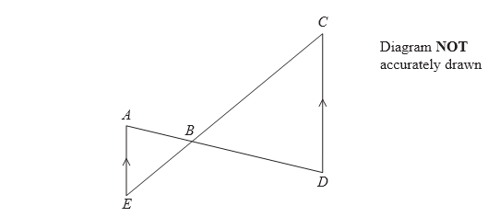

*ABD* and *EBC* are straight lines.

Prove that triangle *ABE* is similar to triangle *DBC*.

Give reasons for each stage of your proof.

**7.**



*ABCD* is a parallelogram.

*E* is the midpoint of *AB*.

*F* is the midpoint of *DC*.

**(a)** Prove that triangle *AED* is congruent to triangle *CFB*.

**(b)** Hence, prove that *DE* = *FB*

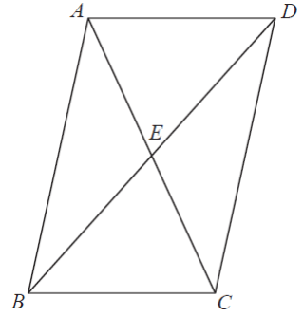**8.** *ABCD* is a parallelogram.

*E* is the point where the diagonals *AC* and *BD* meet.

Prove that triangle *ABE* is congruent to triangle *CDE*.

|  |
| --- |
| **Similar** |

**1.**

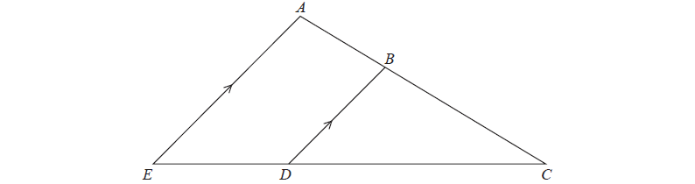

*ABC* and *EDC* are straight lines.

*EA* is parallel to *DB*.

*EC* = 8.1 cm.

*DC* = 5.4 cm.

*DB* = 2.6 cm.

**a)** Work out the length of *AE*.

*AC* = 6.15 cm.

**b)** Work out the length of *AB*.

**2.**



*ABC* and *DEF* are two similar triangles.

Angle *ABC* = Angle *DEF*

Angle *ACB* = Angle *DFE*

Work out the length of *BC*.

**3.** *ABC* is a triangle.



*D* is a point on *AB* and *E* is a point on *AC*.

*DE* is parallel to *BC*.

*AD* = 4 cm, *DB* = 6 cm, *DE* = 5 cm, *AE* = 5.8 cm.

Calculate the perimeter of the trapezium *DBCE*.