Six cubes

Holly has built some different shapes using six multilink cubes each time.
She draws a diagram of each of her shapes using isometric paper.

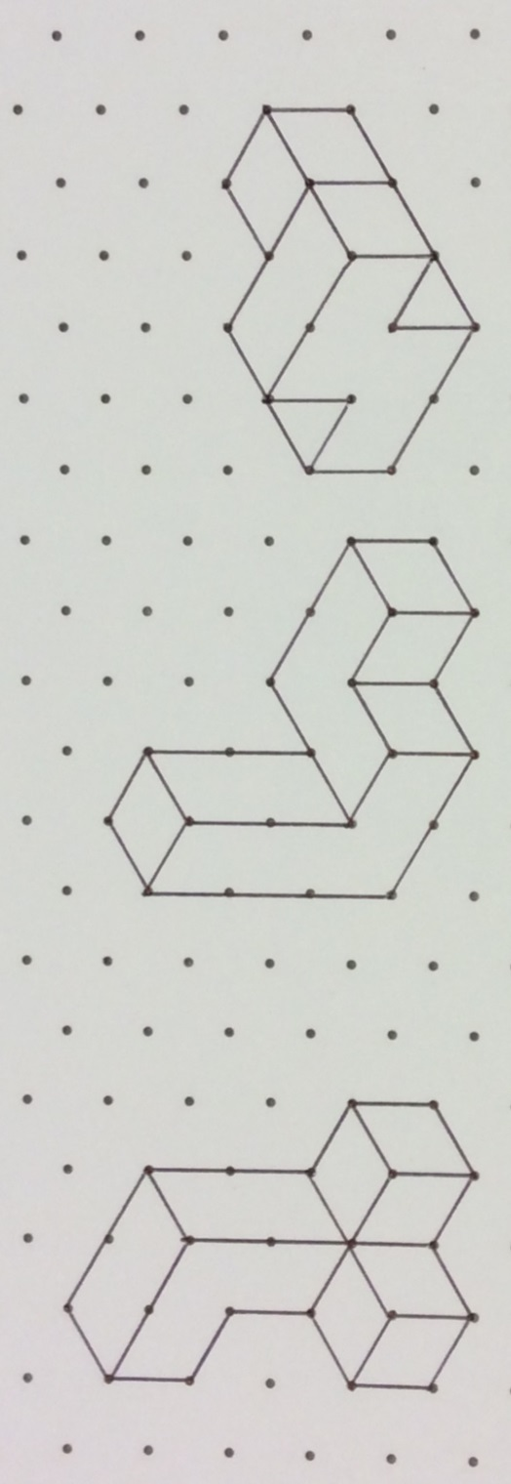

Here is the North elevation of the first shape:

1 Draw the East, West and South elevations of the first shape.

2 Construct the plan of the shape. Add an arrow to show the direction of North.

The other two shapes are in the same orientation.

3 Draw diagrams of the plan and four elevations for each of the shapes.

Eight cubes

Harry has eight multilink cubes. He makes two different shapes using eight cubes each time.
He also draws diagrams on isometric paper.

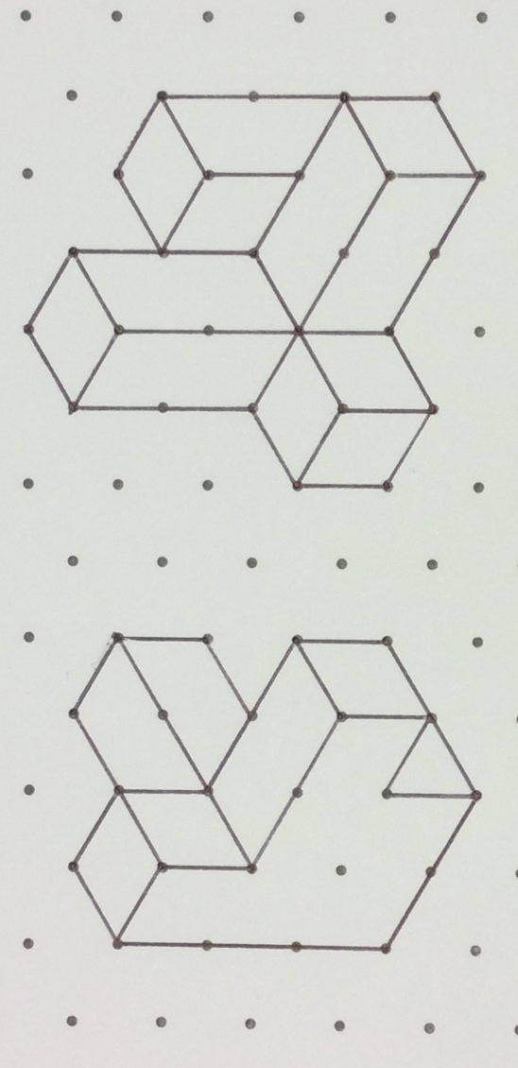

Here is the North elevation of Harry’s first shape:

4 Draw diagrams of the plan and four elevations for each of the shapes

5 Harry also makes this shape

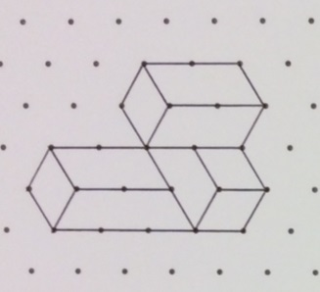

Has he used all eight cubes? Choose the correct answer from the list below. Explain your choice.

Yes | No | Not enough information

