You will need a copy of Ordnance Survey’s map: Outdoor Leisure 13, Brecon Beacons National Park (East). If using a section of this you need the A3 size section including grid squares 19 to 29 horizontally and 18 to 25 vertically.

Task 1
Six figure grid references

Write down the feature at each of these places. If you are unsure of the meaning of the symbol, describe it in words.

- 217224
- 239204
- 230207
- 285212
- 198200
- 255217

Write down the six figure grid reference for each of these places on the map

- Trig point on summit of Sugar Loaf / Y Fal
- Trig point on summit of Pen Allt-mawr
- Trig point on summit of Crug Mawr
- Telephone box to the West of Crug Mawr
- Telephone box in village of Llanbedr
- Telephone box North-East of Crug Mawr

Task 2
Three figure bearings

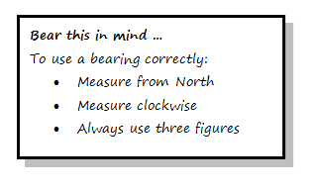
Measure the bearing of each of these places from the summit of Pen Carrig-calch:
- Crug Mawr summit
- Sugar Loaf / Y Fal summit
- Perth-y-pia bunkhouse
- Pen Allt-mawr summit
- Radio Mast 1 kilometre East of Crickhowell

Measure the bearing of:
- Pen Carrig-calch summit from Crug Mawr summit
- Llanbedr church from Perth-y-pia bunkhouse
- Sugar Loaf / Y Fal summit from Crug Mawr summit
- Radio Mast at 206203 from pub at 214191
- Telephone box at 273244 from telephone box at 285212

Task Three
Figure out this

Make up some problems for a friend to solve. Swap questions, work out the problems, and then check each other’s answers.

