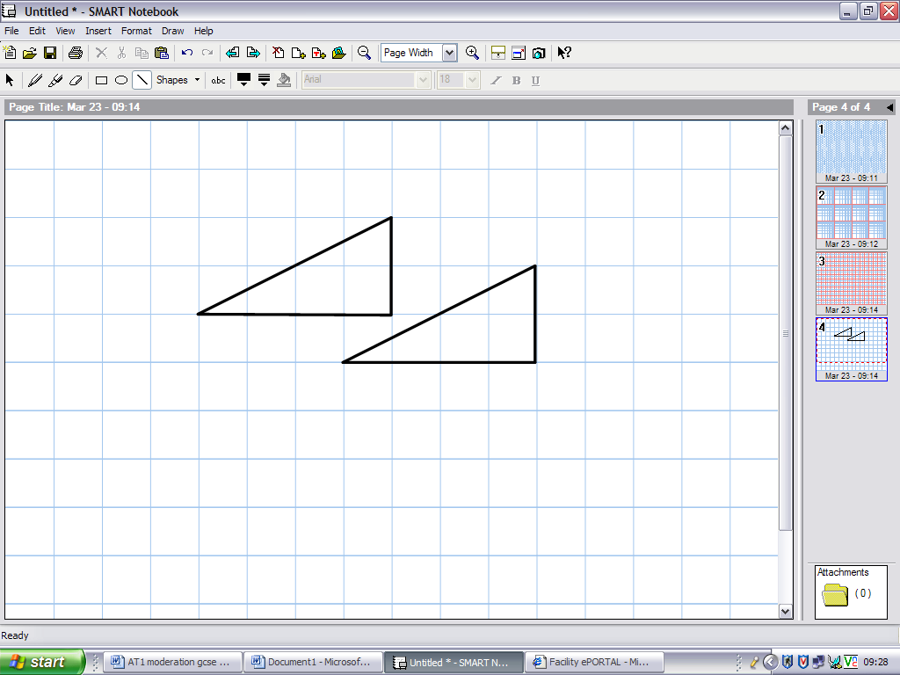**Two Triangles**

Cut out two triangles like these.

Fit them together to make:

* A rectangle
* A parallelogram
* A kite
* A pentagon
* A hexagon
* An acute-angled isosceles triangle
* An obtuse-angled isosceles triangle
* A quadrilateral that is neither a kite nor a parallelogram
* Five different pentagons

Record your answers on spotty or squared paper.

**One Triangle**

Copy this triangle onto squared paper three times.

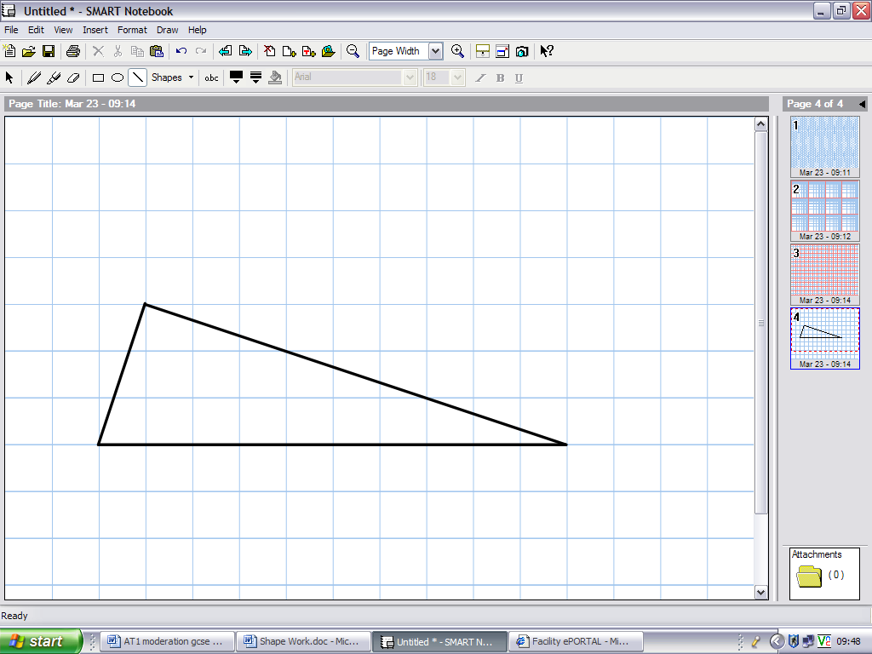

Draw one extra line on each diagram to show how the triangle can be split into:

* Two right-angled triangles
* A right-angled isosceles triangle and an obtuse-angled triangle
* Two isosceles triangles (you will need compasses to help with this one)

**Four Triangles**

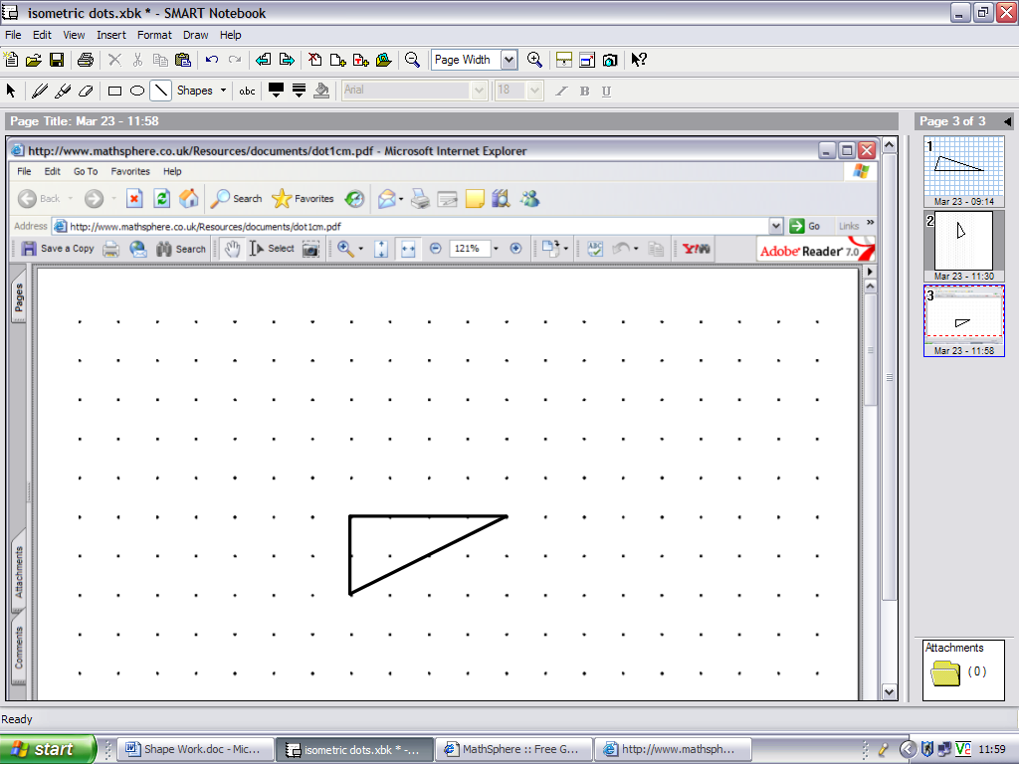

Make as many different quadrilaterals as

you can with four of these triangles:

**The 4×4 Grid**

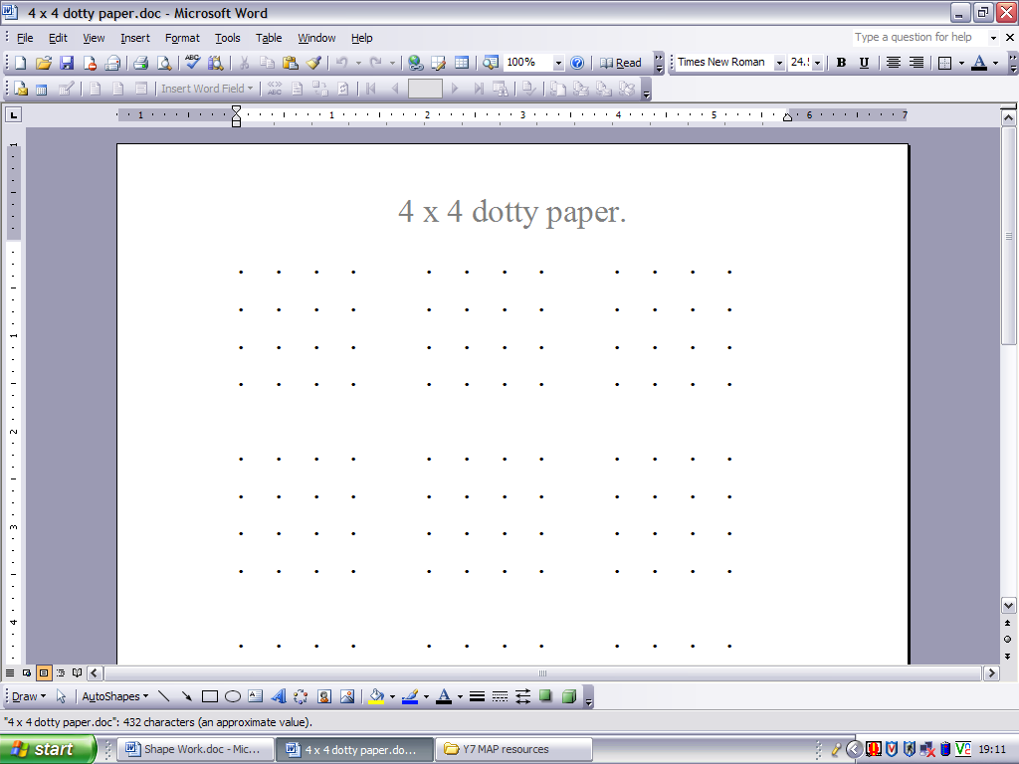

Try to draw the following on a 4×4 grid:

* Five different size squares
* A rhombus - that isn’t a square
* Four different rectangles
* Four different kites
* Nine different parallelograms – that are not rectangles
* Five different trapezia
* Four different arrowheads
* Five different shapes with two lines of symmetry
* The polygon with the largest possible number of sides
* As many different isosceles triangles as you can

**Triangles to Thirds**

Copy these triangles onto isometric paper:

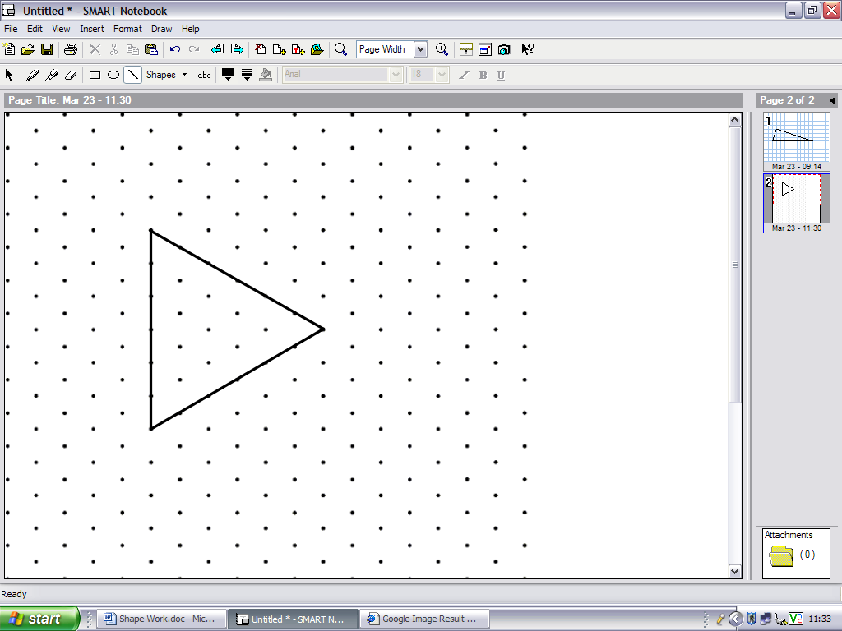 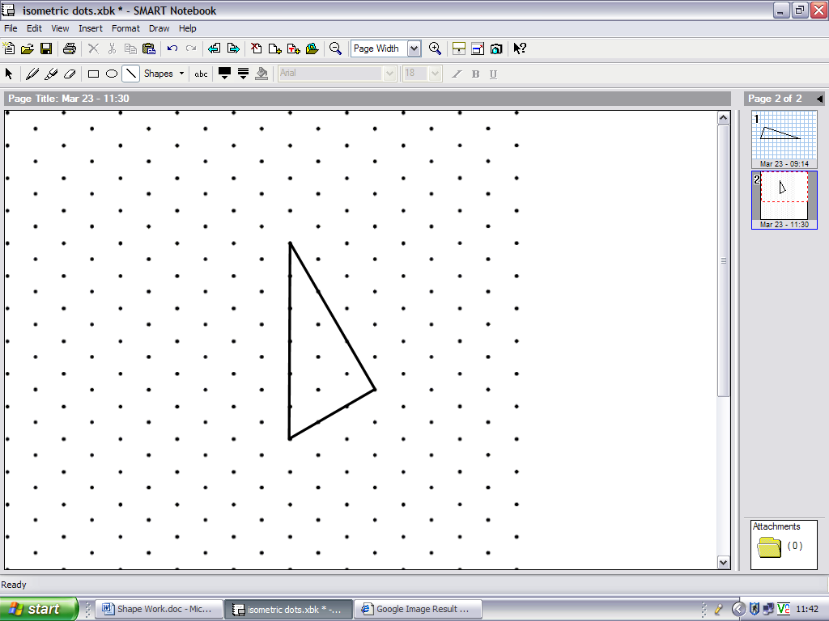

* Divide the equilateral triangle into 3 congruent isosceles triangles
* Now try to divide the right-angled triangle into 3 congruent right-angled triangles
* Can you draw an equilateral triangle on square spotty paper with all vertices on the spots?

**Trapezia**

* Can you cut a parallelogram into two trapezia?
* Can you cut a triangle into three trapezia?

**Divided Triangle**

This triangle has been divided into four quadrilaterals and a triangle.

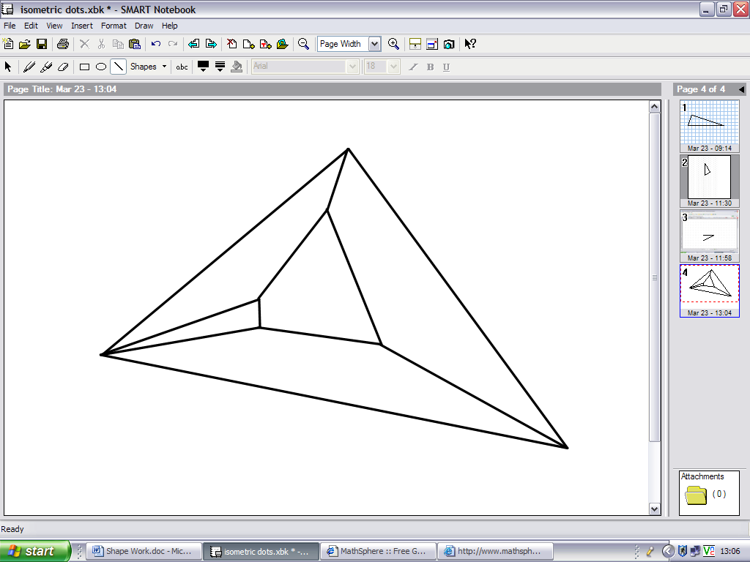

Can you divide it into quadrilaterals only?

*Note: You are not allowed to put any new corners on the sides of the original triangle.*

**Scalene Triangles**

For any scalene triangle how can you draw the largest equilateral triangle with each vertex on one side?

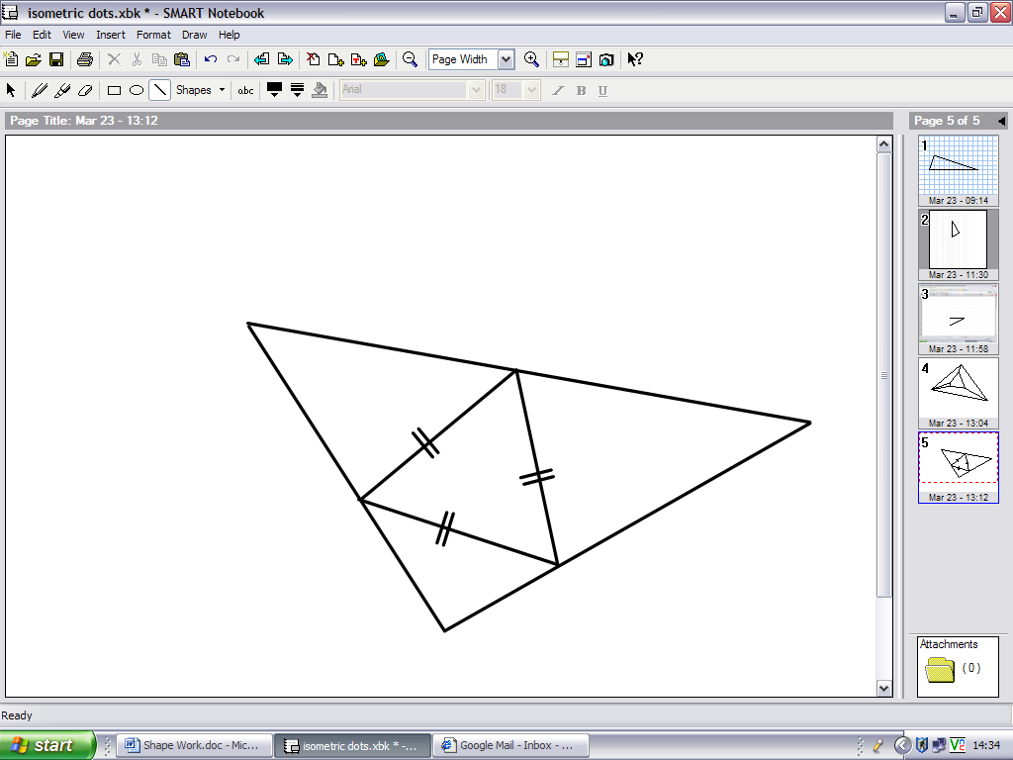

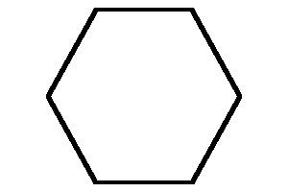**Hexagons**

Draw and cut out three regular hexagons on isometric paper

* Cut one into two pieces that will make a parallelogram
* Cut the second into three pieces which will make a rhombus
* Cut the final hexagon into four pieces which will make two equilateral triangles

**Maps**

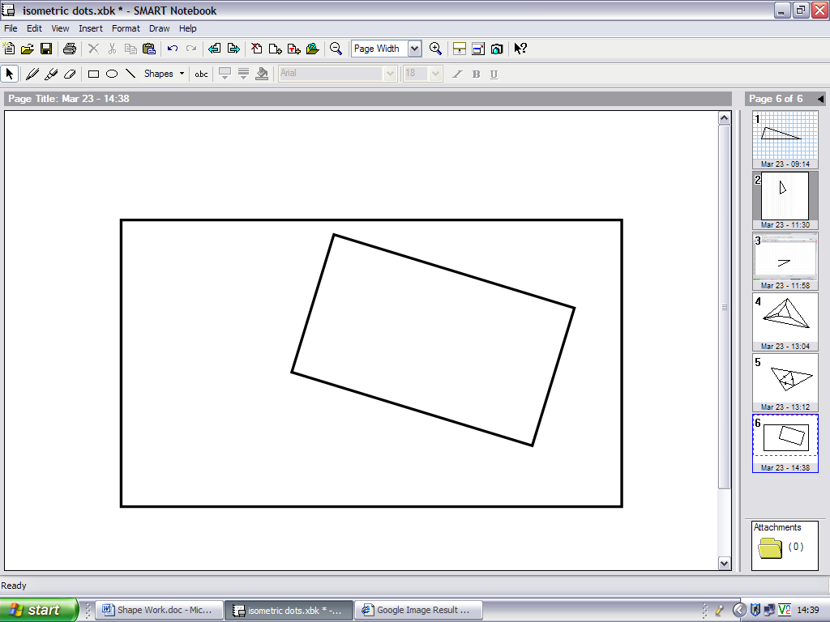

The diagram shows two maps of the same area of land. One scale is exactly double the scale of the other. There is one point on the smaller map which is exactly above its corresponding point on the larger map. How can you find it?

**Rhombi**

How many rhombi can you divide each of the regular polygons into? You might find a polygon template helpful.

**Integer Lengths**

How many different triangles with sides of whole number (integer) length can be drawn having a longest side of length 5 units?

**Polyominoes**

* How many different triominoes are there?
* How many different quadrominoes?

**Packing Squares**

* There are three ways of filling a 3×3 square with just squares. Can you find them?
* Now try a 2×2, 4×4 and 5×5 square.

**Rectangle**

* What is the smallest rectangle which can be made using these two basic shapes?

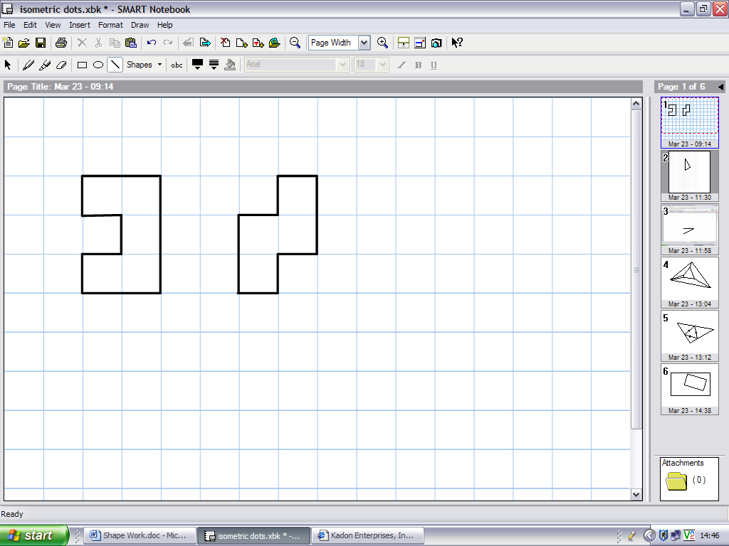

* What is the next smallest such rectangle?

**Pentominoes**

Pentominoes are shapes made up with five squares so that at least one side of each square touches another side. There are twelve possibilities.

* Find them all
* How many ways can you fit two pentominoes into this shape?

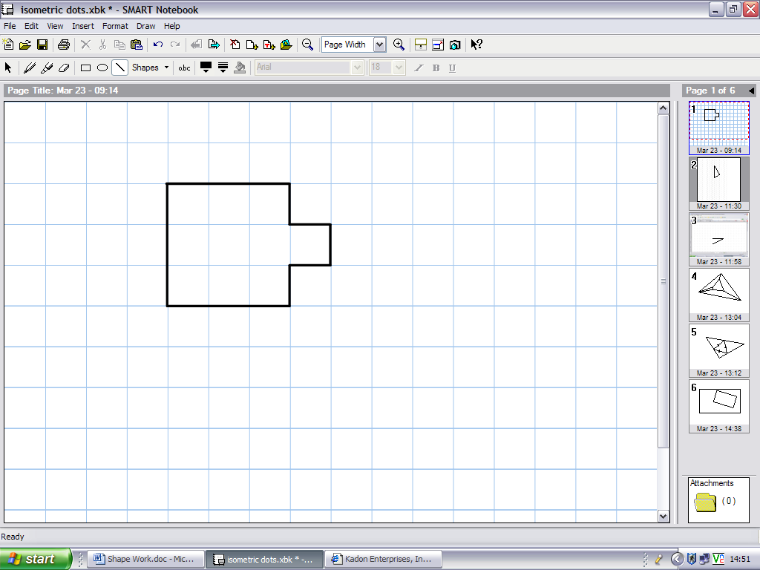

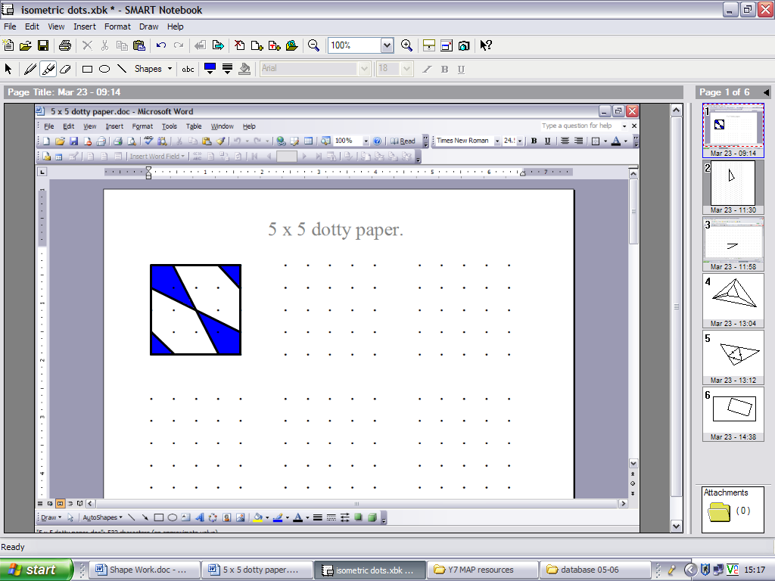**Tiles**

Take some 5×5 squared spotty paper. Points are marked on each edge, a quarter of the way from a corner. Points are joined.

* What different tiles can you make?
* Using one or two tiles, make a pattern using several of your tiles.

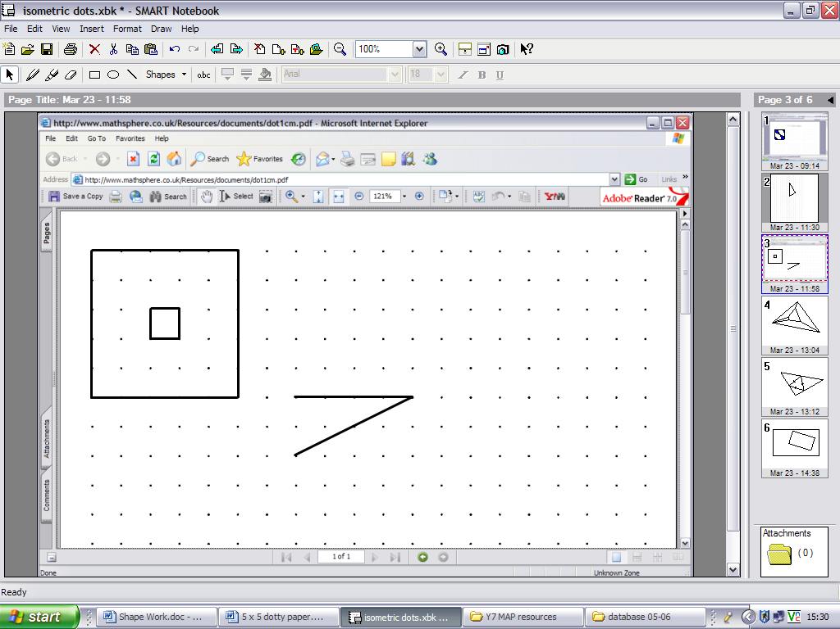**4×4 Square**

* How many different ways can you cut a 4×4 square into 4 congruent pieces?
* How many different ways are there of cutting a 5×5 square (with centre piece missing) into 4 congruent pieces?

**Circle**

Take a ten point circle.

* Can you make a right-angled triangle?
* Can you make a kite?
* How many different rectangles can you make?
* How many different trapezia can you make?
* What shape do you get if you move round the circle in jumps of two?
* What about jumps of three, four and so on?

**Squares**

Using square spotty paper, make a square with an area of:

* 2 squares
* 8 squares
* 18 squares
* 5 squares

**Tangram**

Draw the first shape on dotty paper and cut it out. Now make one further cut so that you can arrange the two resulting pieces into the inverted T-shape.

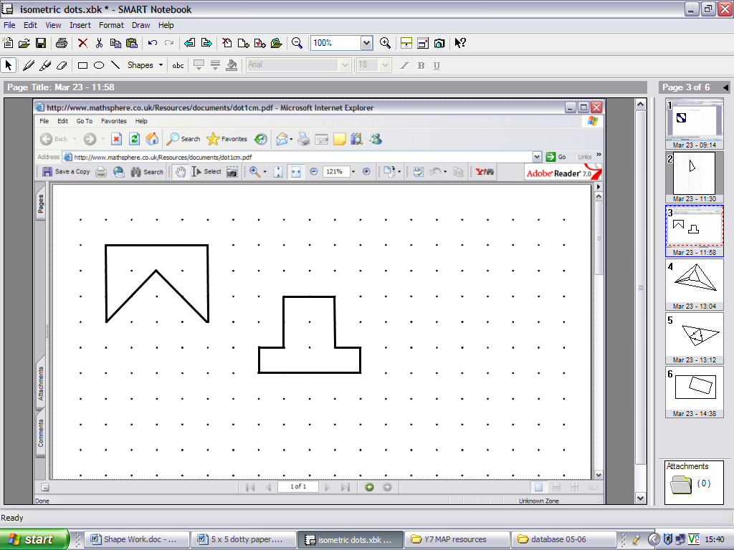

**Dissections**

A 3×3 square is dissected into rectangles and squares such that all the rectangles are different and all the side lengths are integers. How many ways can this be done?

**Rotational Symmetry**

Draw a shape with no lines of symmetry but order of rotational symmetry 4

**Dice**

To make a dice you could use a net like this:

|  |  |  |  |
| --- | --- | --- | --- |
|  | 5 |  |  |
| 4 | 1 | 3 | 6 |
|  | 2 |  |  |

Find all the other possibilities. For each one, put the numbers in the correct places.

**Opposite numbers**

Here are three views of the same cube

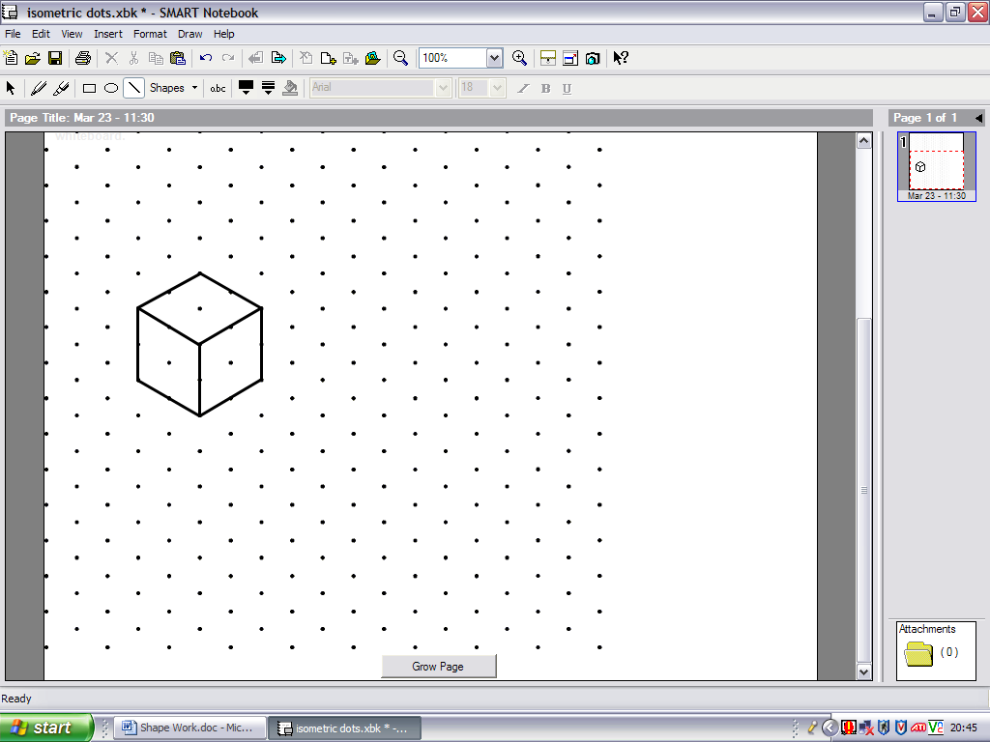

**3**

**6**

**1**

**3**

**2**

**4**

**1**

**2**

**3**

* Which number is opposite 1?
* Which number is opposite 2?
* Which number is opposite 3?

**Similar Shapes**

Make a similar shape that is four times bigger than the original, using four of the original shape. An example is shown below.

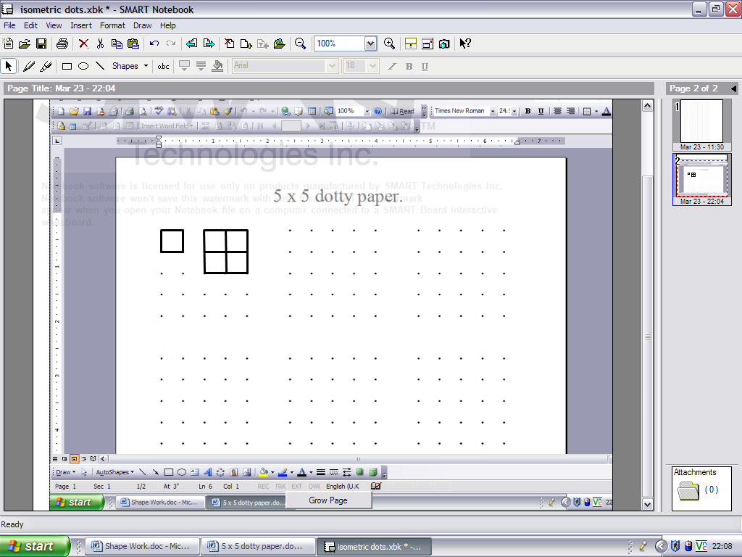

Now try each of these.

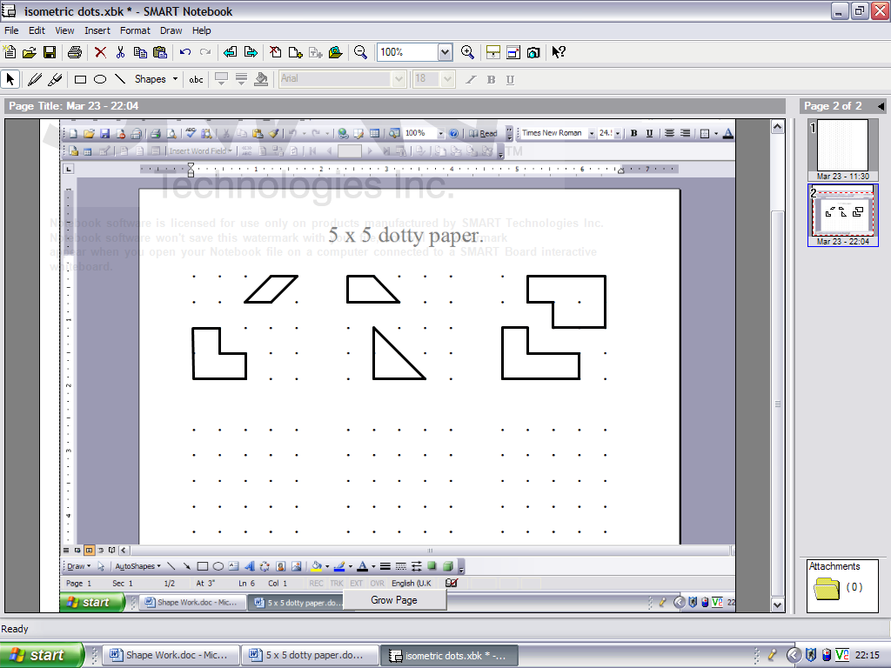

**Symmetrical Hexagons**

Draw a hexagon with:

* 3 lines of symmetry
* 2 lines of symmetry
* 1 line of symmetry
* No lines of symmetry but order of rotational symmetry 2
* No lines of symmetry but order of rotational symmetry 3

**Dotty Squares**

Choose any two points on square spotty paper. An example is shown below.

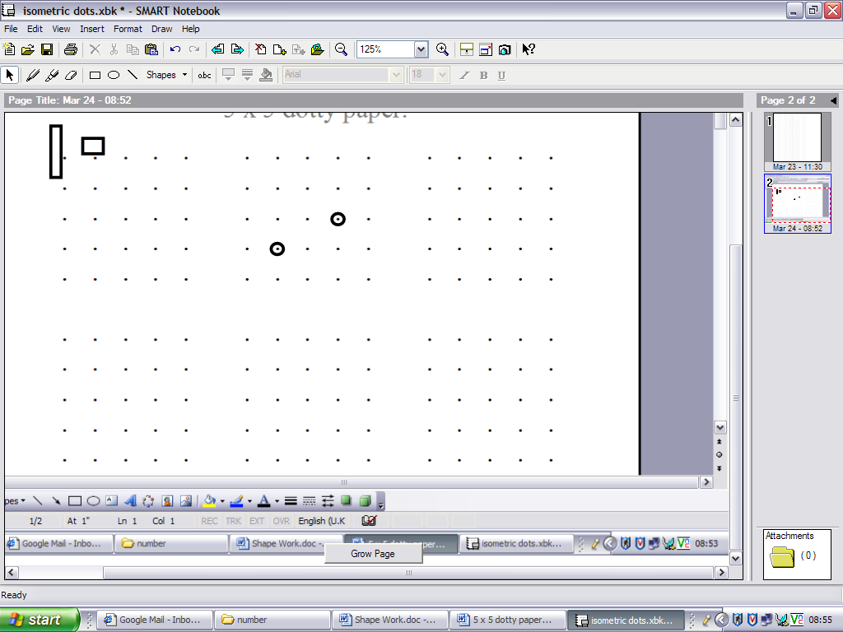

* When can the two points be adjacent corners of a square?
* When can the two points be opposite corners of a square?

**Pentagons**

How many distinct pentagons can you make using these five vertices?

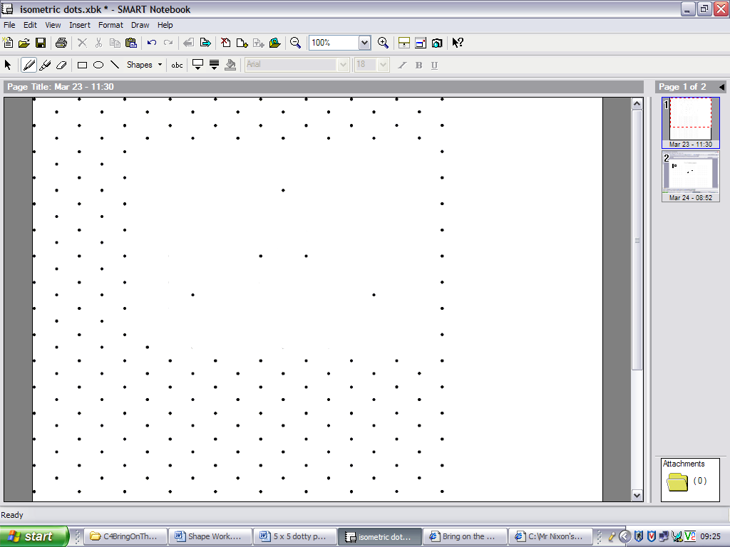

**Cuboids**

* How many different cuboids can you make out of 24 little cubes?
* What are the surface areas of each of these cubes?
* How many different cuboids can you make with a surface area of 40 squares?

**Overlapping Sheets**

Try overlapping two sheets of paper and looking at the different shapes that the overlap makes. List the different shapes that you can make.

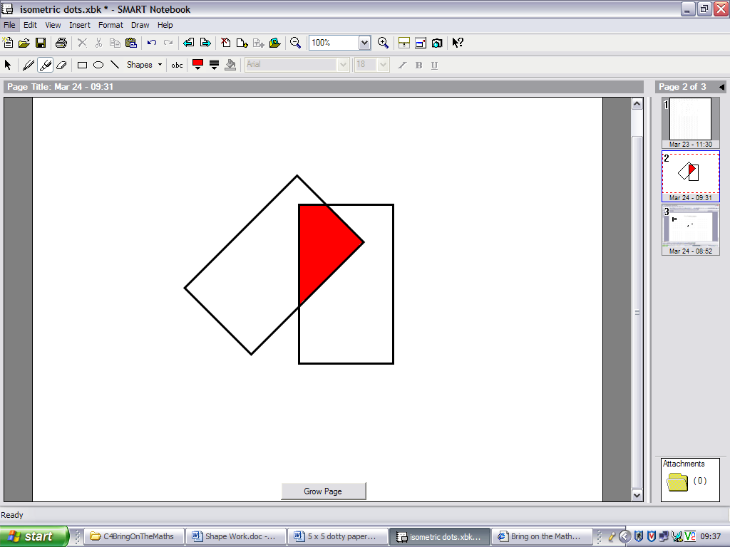

**Cutting Cubes**

What different shapes can be made by cutting a cube?

**Area**

What is the biggest area you can enclose with a perimeter of 24cm …

* … if the vertices have to be spots on square spotty paper?
* … if the vertices have no restrictions?

**Quadrilaterals**

* Write down the names of the seven different special quadrilaterals
* Classify them according to the length of their sides
* Classify them according to the relationship between their diagonals

**Four Lines**

Four lines are drawn on a 3×3 spotty grid as shown below. What is the area of the central square?

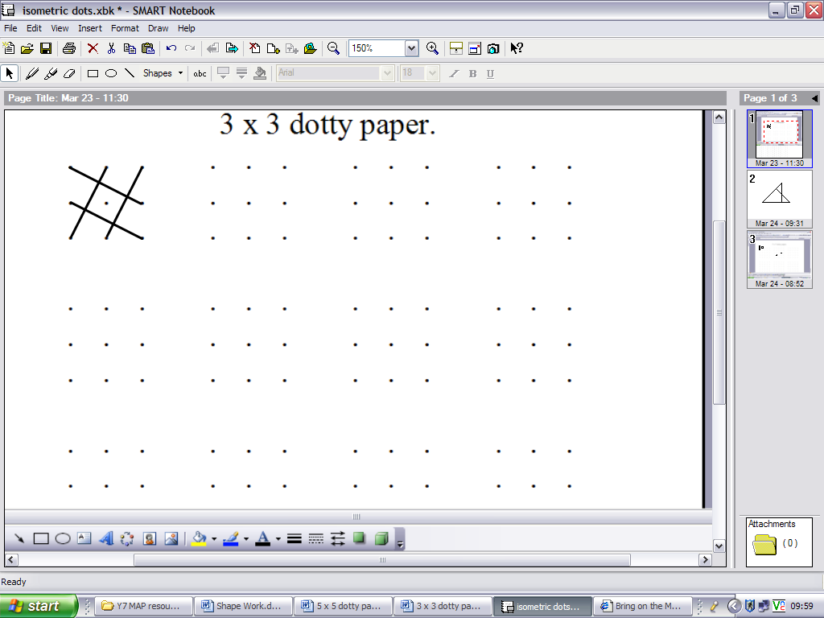

**Congruent Triangles**

Two congruent right-angled isosceles triangles overlap as shown below. What is the area of the overlap?

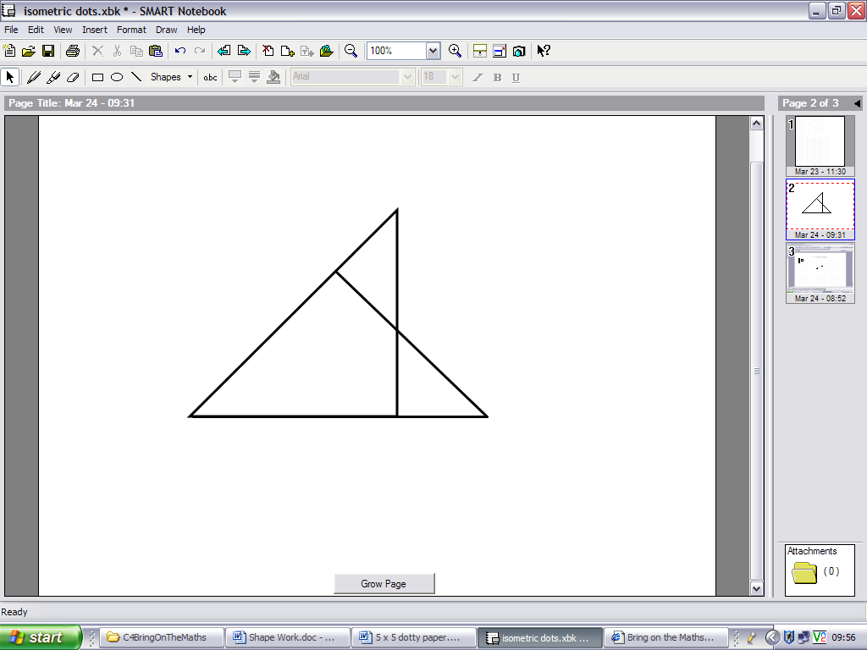

**Pick’s Theorem**

Make several shapes with no dots inside. Some examples are shown below.

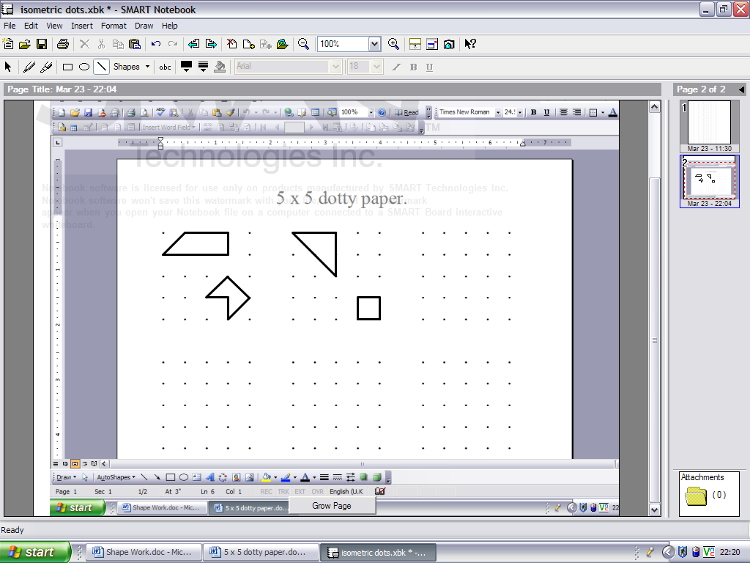

For each shape:

* Find the area
* Find the number of dots on its perimeter
* Repeat the process for some shapes with one dot inside, two dots inside and three dots inside.
* Find a rule that connects area, number of perimeter dots and number of dots inside.

**Painted Cube**

A 3×3×3 cube is made out of little blocks. The outside is painted red. How many little blocks have:

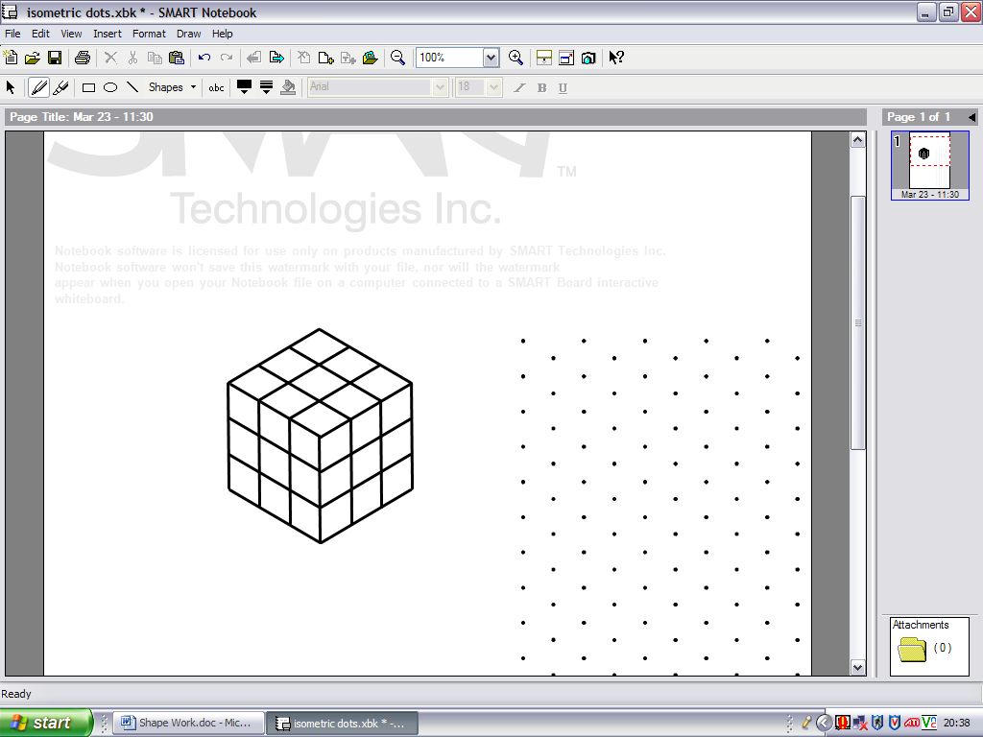

* 3 sides painted?
* 2 sides painted?
* 1 side painted?
* 0 sides painted?

Investigate for different sizes of cubes and cuboids

**Billiards**

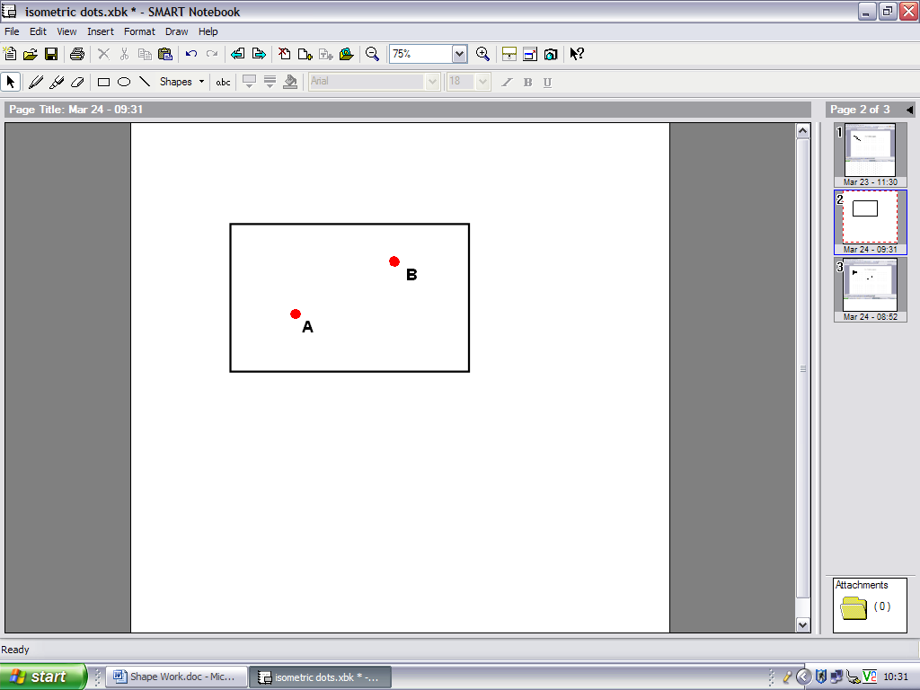

How many different ways are there to get ball A to hit ball B after:

* 1 rebound?
* 2 rebounds?
* 3 rebounds?

You may need to establish some rules for your investigation as you progress.

**Multilink Houses**

* How many different buildings can you make using three cubes?
* How many different buildings can you make using four cubes?
* How many different buildings can you make using five cubes?

**Right Angles**

Use square spotty paper to investigate shapes with eight interior right-angles and four exterior right-angles

*Source unknown*